水平集 IEEE TPAMI2008 （第一篇从密度估计角度研究文本行分割问题的论文）

Script-Independent Text Line Segmentation in Freestyle Handwritten Documents

自由式手写文档中与脚本无关的文本行分割

Yi Li, Student Member, IEEE, Yefeng Zheng, Member, IEEE,David Doermann, Member, IEEE, and Stefan Jaeger

**Abstract**—Text line segmentation in freestyle handwritten documents remains an open document analysis problem. Curvilinear text lines and small gaps between neighboring text lines present a challenge to algorithms developed for machine-printed or hand-printed documents. In this paper, we propose a novel approach based on density estimation and a state-of-the-art image segmentation technique, the level set method. From an input document image, we estimate a probability map where each element represents the probability of the underlying pixel belonging to a text line. The level set method is then exploited to determine the boundary of neighboring text lines by evolving an initial estimate. Unlike connected component-based methods ([1] and [2], for example), the proposed algorithm does not use any script-specific knowledge. Extensive quantitative experiments on freestyle handwritten documents with diverse scripts such as Arabic, Chinese, Korean, and Hindi demonstrate that our algorithm consistently outperforms previous methods [1], [2], [3]. Further experiments show that the proposed algorithm is robust to scale change, rotation, and noise.

手写文档中的文本行分割仍然是一个开放的文档分析问题。曲线文本行和相邻文本行之间的小间隙对为机器打印或手工打印文档开发的算法提出了挑战。在本文中，我们提出了一种基于密度估计的新方法和一种最新的图像分割技术-水平集方法。从输入文档图像中，我们估计一个概率图，其中每个元素表示底层像素属于文本行的概率。然后利用水平集方法通过进化初始估计来确定相邻文本行的边界。与基于连通组件的方法(例如，[1]和[2])不同，所提出的算法不使用任何特定于脚本的知识。在阿拉伯、中文、朝鲜语和印地语等多种文字的自由式手写文档上的大量定量实验表明，我们的算法始终优于以前的方法[1]、[2]、[3]。进一步的实验表明，该算法对尺度变化、旋转和噪声具有较强的鲁棒性。

手写文本行分割、文档图像分析、密度估计、水平集方法

**1 INTRODUCTION**

TEXT line segmentation is one of the major components of document image analysis. It provides crucial information for skew correction, zone segmentation, and character recognition. Although text line segmentation for machineprinted or hand-printed documents is usually seen as a solved problem [4], freestyle handwritten text lines still present a significant challenge. In particular:

1. Handwritten text lines are curvilinear. Linear or piecewise linear approximation is not accurate in general.

2. Neighboring handwritten text lines may be close or touch each other. No well-defined baselines exist for most handwritten documents.

文本分割是文档图像分析的主要组成部分之一。它为倾斜校正、区域分割和字符识别提供了重要信息。尽管机器打印或手动打印文档的文本行分割通常被视为已解决的问题[4]，但自由手写文本行仍然是一个重大挑战。特别是:

1. 手写的文本线条是曲线的。线性或分段线性近似通常不准确。
2. 相邻的手写文本行可能相互靠近或接触。大多数手写文档没有明确的基线。

Fig. 1 shows the segmentation results of the Docstrum algorithm [1], a well-known layout analysis algorithm, on a machine-printed document and a freestyle handwritten document. As we can see, although the algorithm works reasonably well on the machine-printed document, it is still a significant challenge to segment text lines in handwritten documents. Bounding boxes are widely used in machineprinted document analysis to represent the segmentation results of zones, text lines, words, and characters. However, it is not trivial to use bounding boxes to label overlapping curvilinear text lines, as shown in Fig. 1a. A closed curve (or a polygon as an approximation) more appropriately represents the boundary of a text line. Previous text line segmentation methods, such as connected componentbased methods, directly work on the input image (generally, a binary image). For connected component analysis, each pixel is equally treated and a change of one pixel may result in a different result. If two neighboring text lines touch each other through even a single handwritten stroke, the segmentation algorithm fails. We deal with this problem by using a probabilistic approach. The distribution of black pixels in a document is not uniform. At the center of a text line, a pixel is more likely to be a black pixel than at a text line gap. Therefore, we estimate a probability map where each pixel represents the probability that it belongs to a text line. As shown in Fig. 2b, the text line structure is enhanced. Based on the probability map, the boundaries of text lines can be further determined using region growth techniques. To the best of our knowledge, this is the first paper to study the text line segmentation problem from the density estimation perspective. In this paper, we make the following contributions:

1. Unlike previous methods, we estimate the probability density function (PDF) of 2D variables, which represents the text line distribution.
2. With the a priori knowledge that a text line is a horizontally elongated shape, we use a state-of-theart region growth technique to determine the text line boundary based on the PDF.

3. Our approach combines the advantages of the bottom-up and top-down approaches, that is, the script independence of the projection-based methods and the capability of processing a complex layout of the connected-component-based methods.

图1示出了众所周知的布局分析算法Docstrum算法[1](文档谱)对机器打印文档和自由手写文档的分割结果。正如我们所看到的，尽管该算法在机器打印的文档上工作得相当好，但在手写文档中分割文本行仍然是一个重大挑战。边界框广泛用于机器打印文档分析，以表示区域、文本行、单词和字符的分割结果。然而，使用边界框来标记重叠的曲线文本行并不容易，如图1a所示。闭合曲线(或近似多边形)更适合表示文本行的边界。以前的文本行分割方法，例如基于连接组件的方法，直接作用于输入图像(通常是二值图像)。对于连通分量分析，每个像素都被同等对待，一个像素的变化可能导致不同的结果。如果两个相邻的文本行通过一个手写笔画相互接触，分割算法就会失败。我们用概率方法处理这个问题。文档中黑色像素的分布不均匀。在文本行的中心，像素更可能是黑色像素，而不是文本行间隙。因此，我们估计一个概率图，其中每个像素代表它属于一个文本行的概率。如图2b所示，文本行结构被增强。基于概率图，可以使用区域增长技术进一步确定文本行的边界。据我们所知，这是第一篇从密度估计角度研究文本行分割问题的论文。在本文中，我们做出以下贡献:

1. 与以前的方法不同，我们估计2D变量的概率密度函数，它代表文本行分布。
2. 根据文本行是水平拉长形状的先验知识，我们使用区域生长技术来确定基于PDF的文本行边界。
3. 我们的方法结合了自底向上和自顶向下方法的优点，即基于投影的方法的脚本独立性和处理基于连接组件的方法的复杂布局的能力。

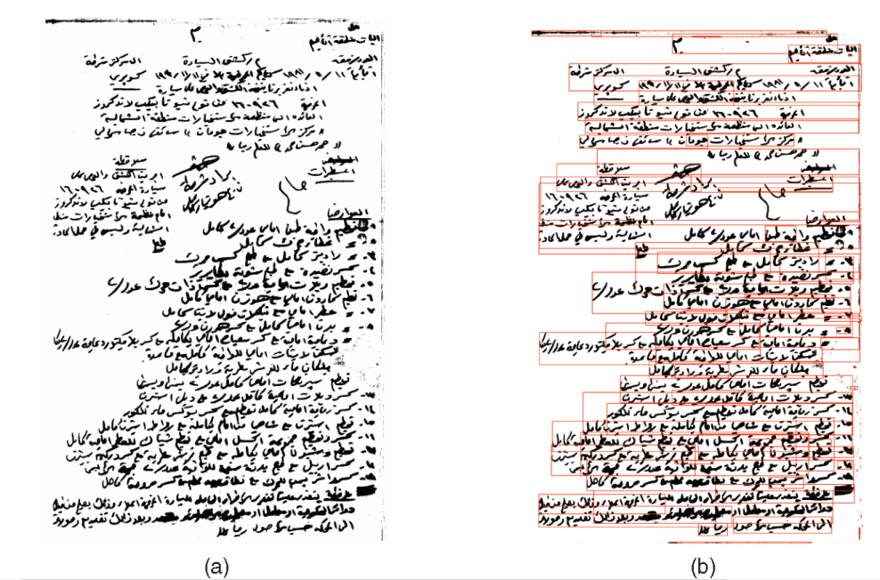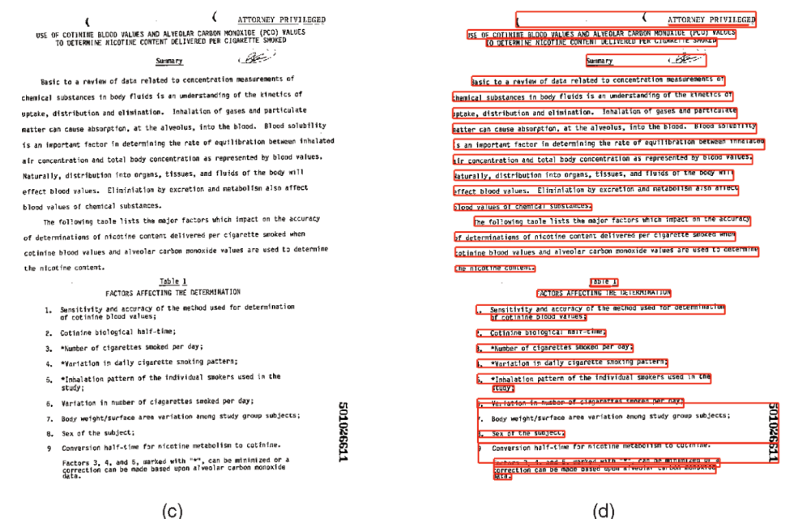图1

1. 手写文档图像。 （b）通过使用边界框使用docstrum方法[1]的文本线分割结果[1]。 （c）机器印刷的文档图像。 （d）通过使用边界框使用docstrum方法[1]的文本线分割结果[1]。
2. L. O’Gorman, “The Document Spectrum for Page Layout Analysis,” IEEE Trans. Pattern Analysis and Machine Intelligence, vol. 15, no. 11, pp. 1162-1173, Nov. 1993.

页面布局分析的文档频谱

Preliminary results of the proposed approach were published in our previous conference proceedings [5], [6]. In this paper, we discuss a novel view of our approach and present extensive quantitative comparison experiments on a large handwriting data set using approximately 10 scripts.

提出的方法的初步结果发表在我们以前的会议记录[5]，[6]上。在本文中，我们讨论了该方法的一种新观点，并使用大约10个脚本在一个大型手写数据集上进行了大量的定量比较实验。

This paper is organized as follows: In Section 2, we review some related materials. Text line density estimation and text line boundary evolution using the level set method are described in Sections 3 and 4, respectively. Section 5 presents an extensive performance evaluation and quantitative comparison of the proposed method and the previous methods on a large handwriting data set. This paper ends with a summary and a brief discussion of our future work.

本文组织如下：在第二节中，我们回顾了一些相关的资料。第3节和第4节分别描述了基于水平集方法的文本行密度估计和文本行边界演化。第五部分在一个大型手写数据集上对所提出的方法和以前的方法进行了广泛的性能评估和定量比较。本文最后对本课题进行了总结，并对下一步的工作进行了简要的讨论。

**2 RELATED WORK**

In this section, we review previous work on text line segmentation in machine-printed documents and some extensions for handwritten documents. The limitations of the previous work on handwritten documents are also discussed.

在这一部分中，我们回顾了以前关于机器打印文档中的文本行分割以及手写文档的一些扩展的工作。文中还讨论了以往手写文档工作的局限性。

* 1. **文档图像中的布局层次结构**

A document can be viewed as an organization of a hierarchical structure of pages, zones, text lines, words, and characters. Layout analysis attempts to extract this hierarchical structure from an image representation [7], [8]. To segment a document at a specified level, previous work on machine printed document analysis relies on the homogeneity inside a region and a significant gap between neighboring regions [9]. Two methodologies, bottom up and top down, were frequently used in previous work for layout analysis [10]. In the bottom-up methodology, connected components are grouped into lines, lines are grouped into zones, and so on. In the top-down methodology, a document page is first segmented into zones, a zone is further segmented into lines, and so on.

文档可以看作是页面、区域、文本行、单词和字符的分层结构的组织。布局分析试图从图像表示中提取这种层次结构[7]，[8]。为了在指定的级别上分割文档，以前关于机器打印文档分析的工作依赖于区域内部的同质性和相邻区域之间的显著差异[9]。两种方法，自下而上和自上而下，在以前的布局分析工作中经常使用[10]。在自下而上的方法中，连接的组件被分组为线，线被分组为区域，等等。在自顶向下的方法中，文档页面首先被分割成区域，区域进一步被分割成行，等等。

Although the techniques for machine printed documents are mature, it is much more challenging to analyze a freestyle handwritten document due to several reasons, including:

1. Non-Manhattan layout at the page level. The irregular page layout cannot be handled by simple rules such as grouping based on geometric relationships of neighboring components.
2. Curvilinear text lines. Linear approximation and regression are not always accurate in general.
3. Connected words. Due to the connectivity between characters and words, it is not trivial to analyze, filter, and process the connected components.

4. Character size variation. Even on the same page, character size can be quite different. It causes problems in estimating the dominant character size, which is an important parameter for the bottom-up connected component-based text line segmentation algorithms [1].

尽管机器打印文档的技术已经成熟，但分析自由手写文档的难度要大得多，原因有几个，包括:

1. 页面级别的非曼哈顿布局。不规则的页面布局无法通过简单的规则来处理，例如根据相邻组件的几何关系进行分组。
2. 曲线文本行。一般来说，线性近似和回归并不总是准确的。
3. 连接词。由于字符和单词之间的连通性，分析、过滤和处理连接的组件并不容易。
4. 字符大小变化。即使在同一页上，字符大小也可能有很大不同。它在估计主导字符大小方面引起问题，主导字符大小是基于自底向上连接组件的文本行分割算法的重要参数[1]。

**2.2文本行分割**

Text line segmentation is important in layout analysis because it serves as the intermediary between page analysis and word segmentation. For example, if we obtain the text lines, we can group them into zones based on the similarity of orientation and alignment or we can further segment text lines into words. Therefore, text lines are crucial for analyzing the hierarchy of document layouts

文本行分割在布局分析中很重要，因为它是页面分析和分词之间的中介。例如，如果我们获得文本行，我们可以根据方向和对齐的相似性将它们分组到区域中，或者我们可以进一步将文本行分割成单词。因此，文本行对于分析文档布局的层次结构至关重要

As a special case of layout analysis, previous text line segmentation algorithms can roughly be categorized as bottom up or top down. In the bottom-up approach, connected component-based methods [2], [11] merge neighboring connected components by using rules based on the geometric relationship between neighboring blocks, such as distance, overlap, and size compatibility. Although connected component grouping techniques can process complex layouts, these methods are sensitive to topological changes in the connected components. For example, a handwritten stroke may cross two neighboring text lines, making two words in two text lines inseparable at the component level. Another disadvantage is that they may be script dependent. For example, spaces occur between neighboring words in English, but a Chinese text line is composed of a string of characters without word spaces. Therefore, it is difficult to derive a script-independent merging rule based on connected components.

作为布局分析的一个特例，以前的文本行分割算法大致可以分为自下而上或自上而下。 在自下而上的方法中，基于连通分量的方法 [2]、[11] 通过使用基于相邻块之间几何关系的规则（例如距离、重叠和大小兼容性）来合并相邻的连通分量。 尽管连接组件分组技术可以处理复杂的布局，但这些方法对连接组件中的拓扑变化很敏感。 例如，手写笔画可能会跨越两个相邻的文本行，从而使两个文本行中的两个单词在组件级别不可分割。 另一个缺点是它们可能依赖于脚本。 例如，英语中相邻单词之间出现空格，而中文文本行是由一串没有单词空格的字符串组成。 因此，很难基于连通分量推导出与脚本无关的合并规则。

1. S. Jaeger, G. Zhu, D. Doermann, K. Chen, and S. Sampat, “DOCLIB: A Software Library for Document Processing,” Proc. SPIE Document Recognition and Retrieval XIII, pp. 63-71, 2006

DOCLIB：用于文档处理的软件库 (基于连通分量的方法)

[11] A. Simon, J.-C. Pret, and A. Johnson, “A Fast Algorithm for Bottom-Up Document Layout Analysis,” IEEE Trans. Pattern Analysis and Machine Intelligence, vol. 19, no. 3, pp. 273-277, Mar. 1997. 自下而上文档布局分析的快速算法 (基于连通分量的方法)

Projection-based methods [3] may be one of the most successful top-down algorithms for machine printed documents. It can be used in many problems such as deskewing [12]. It assumes that the gap between two neighboring text lines is significant, and the projection of text lines is easily separable in the x or y direction. However, this method cannot be directly used in freestyle handwritten documents unless gaps between two neighboring text lines are significant or handwritten text lines are straight [13], [14]. The top-down approaches also have the disadvantage that they cannot process complex non-Manhattan layouts.

基于投影的方法 [3] 可能是机器打印文档最成功的自上而下算法之一。 它可以用于许多问题，例如纠偏[12]。 它假设两个相邻文本行之间的差距很大，并且文本行的投影在 x 或 y 方向上很容易分离。 然而，这种方法不能直接用于自由式手写文档，除非两个相邻文本行之间的间隙很大或手写文本行是直的 [13], [14]。 自上而下的方法还有一个缺点，即它们无法处理复杂的非曼哈顿布局。

1. G. Nagy, S. Seth, and M. Viswanathan, “A Prototype Document Image Analysis System for Technical Journals,” Computer, vol. 25, no. 7, pp. 10-22, July 1992 技术期刊的原型文档图像分析系统
2. B. Yu and A. Jain, “A Robust and Fast Skew Detection Algorithm for Generic Documents,” Pattern Recognition, vol. 29, no. 10, pp. 1599-1629, 1996. 通用文档的稳健且快速的倾斜检测算法
3. R. Manmatha and J.L. Rothfeder, “A Scale Space Approach for Automatically Segmenting Words from Historical Handwritten Documents,” IEEE Trans. Pattern Analysis and Machine Intelligence, vol. 27, no. 8, pp. 1212-1225, Aug. 2005. 从历史手写文档中自动分割单词的尺度空间方法
4. U.-V. Martin and H. Bunke, “Text Line Segmentation and Word Recognition in a System for General Writer Independent Handwriting Recognition,” Proc. Sixth Int’l Conf. Document Analysis and Recognition, pp. 159-163, 2001 通用作家独立手写识别系统中的文本行分割和单词识别
5. nf. Document Analysis and Recognition, pp. 281-285, 2001. 阿拉伯语手写文本行提取

Text line segmentation approaches for machine printed documents are often based on the assumption of straight text lines. This assumption fails in a freestyle handwritten document, where text lines are often curvilinear. Some approaches, such as the projection-based methods, can be extended to deal with slightly curved text lines. Tripathy and Pal [15] proposed a method of dividing the image into multiple columns by using a projection-based method in each column and combining the results of adjacent columns into a longer text line. Generally, they achieved better results than naive methods, but the results of two adjacent columns may be ambiguous, so it is still difficult to generate good results. The performance of connected componentbased methods on a handwritten document can also be improved by estimating the local orientation of the text line and using it to guide the merging of connected components [2]. Other researchers proposed different assumptions for their specific case [16] or for a specific script [17].

机器打印文档的文本行分割方法通常基于直线文本行的假设。 这种假设在自由式手写文档中失败，其中文本行通常是曲线的。 一些方法，例如基于投影的方法，可以扩展到处理稍微弯曲的文本行。 Tripathy 和 Pal [15] 提出了一种将图像分成多列的方法，在每一列中使用基于投影的方法，并将相邻列的结果组合成一个较长的文本行。 一般来说，它们比朴素的方法取得了更好的结果，但是相邻的两个列的结果可能是不明确的，所以仍然很难产生好的结果。 通过估计文本行的局部方向并使用它来指导连接组件的合并，也可以提高基于连接组件的方法在手写文档上的性能[2]。 其他研究人员针对他们的特定案例 [16] 或特定脚本 [17] 提出了不同的假设。

1. N. Tripathy and U. Pal, “Handwriting Segmentation of Unconstrained Oriya Text,” Proc. Ninth Int’l Workshop Frontiers in Handwriting Recognition, pp. 306-311, 2004. 无约束 Oriya 文本的手写分割
2. U. Pal and P.P. Roy, “Multioriented and Curved Text Lines Extraction from Indian Documents,” IEEE Trans. Systems, Man, and Cybernetics—Part B: Cybernetics, vol. 34, no. 4, pp. 1676-1684, 2004. 从印度文档中提取多向和弯曲的文本行

A. Zahour, B. Taconet, P. Mercy, and S. Ramdane, “Arabic Handwritten Text-Line Extraction,” Proc. Sixth Int’l Co

Rule lines often guide a person’s writing [18]. Writers either write above rule lines (for example, in Chinese) or cross the rule lines (for example, in Hindi). If the writing follows the rule lines, text line segmentation may be easier since rule lines provide hints about the text line structure. However, if rule lines are ignored by the writer, they degrade the performance. For example, rule lines make connected component analysis difficult. Projection profile analysis also has problems in determining peaks and valleys given rule lines. In freestyle handwritten documents, most cases lie in the middle of these two extremes. Some text lines follow the rule lines well, while other text lines may cross multiple rule lines.

规则线通常指导一个人的写作 [18]。 作家要么写在规则线上方（例如，用中文）或越过规则线（例如，用印地语）。 如果书写遵循规则行，则文本行分割可能更容易，因为规则行提供了有关文本行结构的提示。 然而，如果规则行被作者忽略，它们会降低性能。 例如，规则线使连通分量分析变得困难。 投影轮廓分析在确定给定规则线的峰谷时也存在问题。 在自由式手写文档中，大多数情况处于这两个极端的中间。 一些文本行很好地跟随规则线，而其他文本行可能跨越多个规则线。

[18]Y. Zheng, H. Li, and D. Doermann, “A Parallel-Line Detection Algorithm Based on HMM Decoding,” IEEE Trans. Pattern Analysis and Machine Intelligence, vol. 27, no. 5, pp. 777-792, May 2005. 基于 HMM 解码的平行线检测算法

**3文本线密度估计**

In this section, we describe the motivation for estimating a probability map from an input image and discuss the nonparametric method used in our approach. Without loss of generality, we assume that character pixels are black and are represented as “1”s in a binary image, while background pixels are white and “0”s. We also assume that the orientations of text lines are locally uniform and a skew correction method can normalize the text lines to orient horizontally. A relatively large variation in orientation, for example, up to ±10°, is still allowed. However, zone segmentation [19] may be necessary to separate text lines with different orientations (for example, horizontal versus vertical) into different zones if they appear on the same document.

在本节中，我们将描述从输入图像估计概率图的动机，并讨论我们的方法中使用的非参数方法。 不失一般性，我们假设字符像素是黑色的，在二值图像中用“1”表示，而背景像素是白色和“0”。 我们还假设文本行的方向是局部一致的，并且倾斜校正方法可以将文本行标准化为水平方向。 仍然允许相对较大的方向变化，例如高达 ±10°。 然而，区域分割 [19] 可能需要将具有不同方向（例如，水平与垂直）的文本行分成不同的区域，如果它们出现在同一文档中。

[19] J. Sauvola, D. Doermann, and M. Pietikainen, “Locally Adaptive Document Skew Detection,” Proc. SPIE Document Recognition and Retrieval IV, pp. 96-108, 1997. 本地自适应文档倾斜检测

**3.1 Motivation**

For decades, directly performing segmentation on a binary image has been accepted without criticism, although it happens that some difficulties are inherently involved. No evidence exists that humans solely use traditional methods such as projection profile analysis to segment handwritten text lines. The computer algorithms, of course, do not necessarily mimic human behavior, but human behavior may give us some insights to explore for better algorithms. A certain pattern naturally occurs when human beings write text lines in documents. For example, the writing speed may remain almost constant within a paragraph, so distances between two adjacent text lines are usually similar. This motivates us to consider the PDF that generates this pattern. Instead of directly segmenting on a binary image, we convert it to a probability map, where each element represents the probability of this pixel belonging to a text line. For visualization, we rescaled the probability map to a gray-scale image (see Fig. 2b). This estimated probability map offers many working advantages. We can avoid calculating some geometric properties such as centroid and connected component size in the beginning because they are not accurate for handwritten documents. Another advantage is that we can adopt many state-of-the-art algorithms to analyze the twodimensional density function. Finally, our method is not limited to binary images and can be used for gray-scale and color images.

几十年来，直接对二值图像进行分割已经被接受而没有受到批评，尽管碰巧存在一些固有的困难。 没有证据表明人类仅使用投影轮廓分析等传统方法来分割手写文本行。 当然，计算机算法不一定模仿人类行为，但人类行为可能会给我们一些见解，以探索更好的算法。 当人类在文档中写入文本行时，自然会出现某种模式。 例如，一个段落内的书写速度可能几乎保持不变，因此两个相邻文本行之间的距离通常是相似的。 这促使我们考虑生成此模式的 PDF。 我们不是直接对二值图像进行分割，而是将其转换为概率图，其中每个元素表示该像素属于文本行的概率。 为了可视化，我们将概率图重新缩放为灰度图像（见图 2b）。 这种估计的概率图提供了许多工作优势。 我们可以避免在开始时计算一些几何属性，例如质心和连通分量大小，因为它们对于手写文档不准确。 另一个优点是我们可以采用许多最先进的算法来分析二维密度函数。 最后，我们的方法不限于二值图像，可用于灰度和彩色图像。

**3.2使用各向异性核的密度估计**

Given an input binary image I(x,y), for x=1...M and y=1...N, we want to estimate the probability map PDF_est（x,y） for 1 ≤ x ≤ M and 1≤y≤M from the observation I(x,y). Kernel-based nonparametric methods are widely used in statistics. Given a continuous Gaussian kernel φ in a 2D space, the kernel-based estimate is

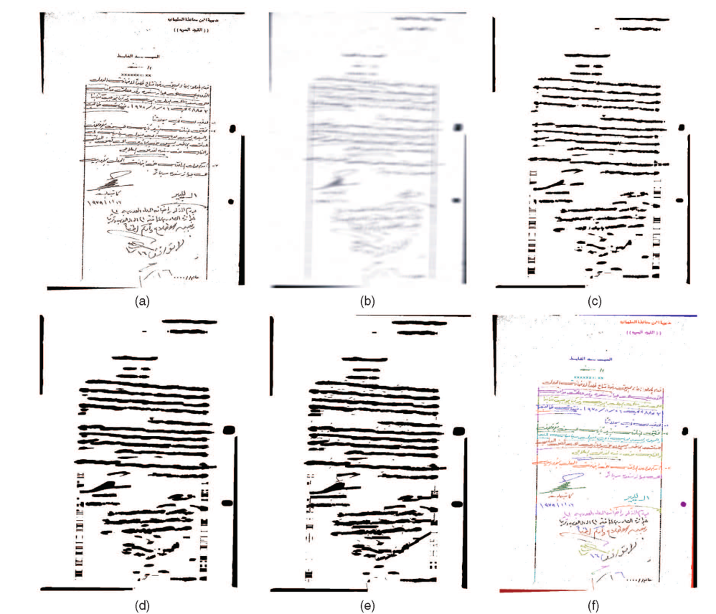图2（a）手写文本 （b）使用各向异性核的密度估计 （c）初始估计文本行 （d）使用水平集方法进行10次迭代的结果 （e）连接几个断开的文本行并将孤立的连接组件分组（后处理） （f）最终文本线分割结果

给定一个输入二值图像 I(x,y)，对于 x=1...M 和 y=1...N，我们要估计概率图 PDF_est（x,y） for 1 ≤ x ≤ M 和 1 ≤y≤M 来自观测值 I(x,y)。 基于核的非参数方法广泛用于统计学。 给定二维空间中的连续高斯核 φ，基于核的估计为

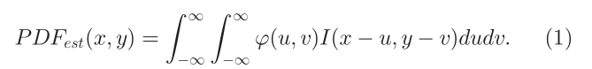

For computational efficiency, the support region of the Gaussian kernel is often truncated in discrete implementation. If the standard deviations in the x and y directions are δx and δy, respectively, the window size is chosen as 3δx and 3δy to minimize the truncation error. The estimated probability map PDFest（x,y）has high density values (dark, as shown in Fig. 2b) on the text lines but low density values (light) for the gaps.

为了计算效率，高斯核的支持区域通常在离散实现中被截断。 如果 x 和 y 方向的标准偏差分别为 δx 和 δy，则窗口大小选择为 3δx 和 3δy 以最小化截断误差。 估计的概率图 PDFest（x,y）在文本行上具有高密度值（暗，如图 2b 所示），但对于间隙具有低密度值（亮）。

Parzen window techniques guarantee that the result PDF is continuous and smooth if a Gaussian kernel is adopted, which is good for boundary selection. For example, we can use the gradient-based methods for our purpose, as presented in the next section. In addition to its theoretical advantage, this technique is also practically meaningful. As shown in Fig. 2b, the details that are irrelevant to the task of text line segmentation such as the script, content of the text, and word gaps have been blurred, while the text line structures are enhanced.

如果采用高斯核，Parzen窗口技术保证了结果PDF的连续性和平滑性，有利于边界选择。例如，我们可以使用基于梯度的方法来达到我们的目的，如下一节所述。除了理论上的优势，这种技术也有实际意义。如图2b所示，与文本行分割任务无关的细节，如脚本、文本内容和单词间隙已经模糊，而文本行结构得到增强。

**4确定文本线边界**

Peaks on the estimated probability map represent text lines, while valleys are between neighboring text lines boundaries, as shown in Fig. 2b. We use a closed curve to represent the text line boundary. To obtain a unique segmentation, two adjacent text line regions should not overlap and their boundaries should not cross. Thresholding may give a reasonable segmentation result. However, the segmented text lines may be fragmented, as shown in Fig. 2c. This initial estimate of the text line boundary must evolve by considering the image information to obtain the final accurate segmentation results. Similar problems related to continuous regions and their boundaries have been studied in modern geometry and fluid mechanics theories. The continuous closed boundaries evolve to their desired location under the guidance of a partial differential equation (PDE). The level set method [20] is an effective algorithm in which the closed level set can automatically grow and merge. It has successfully been adopted in many fields, such as fluid mechanics, computer animation, and computer vision. The level set method naturally deals with topological changes and guarantees no overlapping in different regions, so it is well suited for our application. In this section, we adopt the level set method for the boundary evolution.

如图2b所示，估计概率图上的峰值代表文本行，而谷位于相邻文本行边界之间。我们用一条封闭的曲线来表示文本线的边界。为了获得唯一的分割，两个相邻的文本行区域不应该重叠，并且它们的边界不应该交叉。阈值化可以给出合理的分割结果。然而，如图2c所示，分段的文本行可能是分段的。文本行边界的这种初始估计必须通过考虑图像信息来进化，以获得最终的精确分割结果。现代几何和流体力学理论已经研究了与连续区域及其边界有关的类似问题。在偏微分方程的指导下，连续的闭合边界演化到它们期望的位置。水平集方法[20]是一种有效的算法，其中封闭水平集可以自动增长和合并。它已经成功地应用于许多领域，如流体力学、计算机动画和计算机视觉。水平集方法自然地处理拓扑变化，并保证不同区域没有重叠，因此非常适合我们的应用。在这一部分，我们采用水平集方法进行边界演化。

* 1. **Level Set Method**

对于水平集方法的基本思想，边界由它的偏导数和外部向量场演化。水平集方法的具体公式可以写成如下[23]:

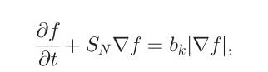(2)

where f is the implicit function and its zero level set represents a boundary, t denotes the time, and represents the movement of the implicit function across time. The movement is controlled by bk, which is usually the curvature of the boundary, and the scalar SN, which is the movement speed of the boundary in the normal direction.

其中 f 是隐函数，其零水平集表示边界，t 表示时间，表示隐函数随时间的移动。 运动由bk（通常是边界的曲率）和标量SN（边界在法线方向的移动速度）控制。

In the level set method, the closed boundary of a text line is represented by an implicit function f, which has negative values inside, positive values outside, and a zero value for the boundary. We then evolve the function and keep tracking the zero level set according to the PDE (2). Thus, the zero level set automatically grows, merges, and stops to the final text line boundary, guided by the PDE. The numerical solution of (2) is based on a grid. First, an initial estimate of the function is calculated and, then, the function is updated on a discrete grid. Each update is also called one iteration.

在水平集方法中，文本行的封闭边界由隐函数 f 表示，该函数内部为负值，外部为正值，边界为零值。 然后我们演化函数并根据 PDE (2) 继续跟踪零水平集。 因此，零级别集在 PDE 的引导下自动增长、合并并停止到最终文本行边界。 (2) 的数值解基于网格。 首先，计算函数的初始估计，然后在离散网格上更新函数。 每次更新也称为一次迭代。

* 1. **文本行边界演化**

The level set method is a general framework. In order to achieve good results for a specified application, domain knowledge should be exploited. In this section, we discuss our modifications under the framework of the level set method for text line boundary evolution.

水平集方法是一个通用框架。 为了在指定的应用程序中取得良好的结果，应该利用领域知识。 在本节中，我们将在文本行边界演化的水平集方法的框架下讨论我们的修改。

To evolve the text line boundary, we need an initial estimate of the text lines. Pixels with high density values allow a suitable initial estimate (see Fig. 2c). Global or local adaptive thresholding (such as the Niblack method [24]) can be used for this purpose. The initial estimate need not be very accurate. As long as at least one part of a text line is extracted, we can achieve a good final segmentation.

为了演化文本行边界，我们需要对文本行进行初始估计。 具有高密度值的像素允许进行合适的初始估计（见图 2c）。 全局或局部自适应阈值（例如 Niblack 方法 [24]）可用于此目的。 初始估计不需要非常准确。 只要提取文本行的至少一部分，我们就可以实现良好的最终分割。

Text lines tend to be directional (for example, horizontal in our case). We can tune the level set method to exploit this a priori knowledge. In particular:

1. We force the boundary to grow faster in the horizontal direction by setting the horizontal update step larger than the vertical step. It is equivalent to compressing the image in the horizontal direction and updating the implicit function f by using the same step in both directions, but our approach is more efficient.
2. Curvature is adopted using a strategy called “the rich get richer”: The bk in (2) is set to the square of actual curvature. By our assumption, text lines are horizontally elongated; therefore, curvatures of the left and right ends of boundaries are larger than those of the top and bottom, which means that the text line tends to grow faster in the horizontal direction.

文本行往往是有方向的（例如，在我们的例子中是水平的）。 我们可以调整水平集方法来利用这个先验知识。 特别是:

1. 我们通过将 水平更新步长 设置 为大于 垂直步长 来强制边界在水平方向上增长得更快。 它相当于在水平方向压缩图像并在两个方向使用相同的步骤更新隐函数 f，但我们的方法更有效。
2. 曲率采用一种称为“富者愈富”的策略：（2）中的bk设置为实际曲率的平方。 根据我们的假设，文本行被水平拉长； 因此，边界的左右两端的曲率大于顶部和底部的曲率，这意味着文本行在水平方向上的增长速度更快。

In our experiments, the density estimation PDFest serves as the normal speed SN. Using PDFest as the speed, the boundary will grow faster inside the text lines, where black pixel densities are large, and slower when it approaches gaps. Thus, PDFest actually controls the speed of the boundary.

在我们的实验中，密度估计 PDFest (估计的概率图)作为正常速度 SN。 使用 PDFest 作为速度，边界将在文本行内增长得更快，其中黑色像素密度很大，并且在接近间隙时增长得更慢。 因此，PDFest 实际上控制了边界的速度。

Another constraint that we want to enforce under the framework of the level set method is to allow merging of boundaries only in the horizontal direction. However, a merge in a vertical direction can happen after each iteration if nothing prevents it. To solve this problem, we need to detect the merge when the boundary evolves.

我们希望在水平集方法框架下实施的另一个约束是仅允许在水平方向上合并边界。 但是，如果没有任何阻碍，则每次迭代后都可能发生垂直方向的合并。 为了解决这个问题，我们需要在边界演化时检测合并。

At time t, we retrieve the zero level set and we obtain N bounding boxes of closed region , n =1,...,N. Suppose that, after iteration t+1, the zero level sets are , n =1,...,M, M ≤ N. For each , it must contain one or more regions of s since all regions are growing. Assume that  contains but is not limited to  and . We adopt a geometry-based detection to evaluate  and . A collision happens if  overlaps  in the horizontal direction. One reasonable criteria is

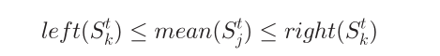

or 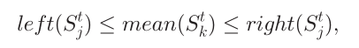

在时间 t，我们检索零级集，并获得封闭区域  的 N 个边界框，n =1,...,N。 假设在迭代 t+1 次之后，零级集为  , n =1,...,M, M ≤ N。对于每个，它必须包含一个或多个  区域，因为所有区域都在增长。 假设包含但不限于和。 我们采用基于几何的检测来评估 和 。 如果在水平方向与  重叠，则会发生碰撞。 一个合理的标准是

（3）

或 （4）

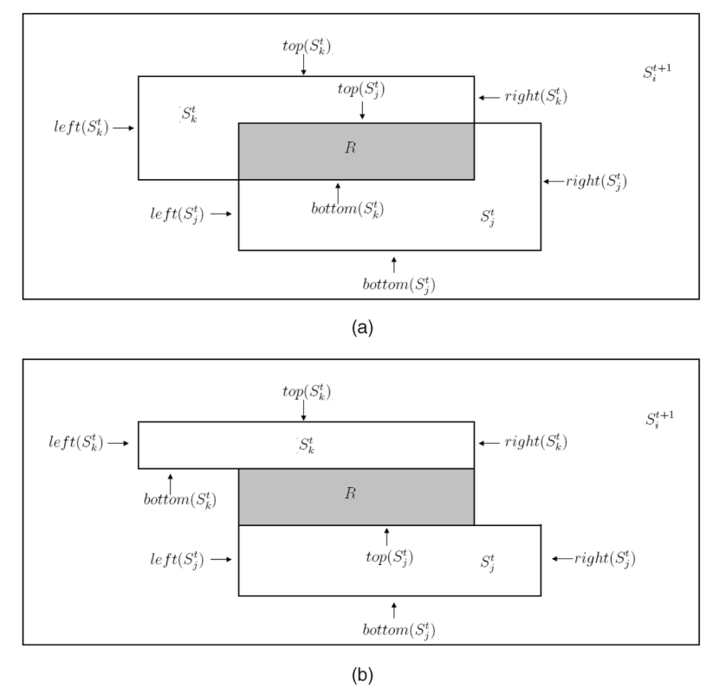

图3.碰撞的插图

where mean（） is the x component of the center of gravity of . right  
（）and left（）are the x components of the right and left ends of , respectively.

其中 mean（）是 的重心的 x 分量。 right（）和left（）分别是的左右两端的x分量。

If (3) or (4) holds, a collision happens. We then calculate the collision region R as follows: Without loss of generality, we assume that is under in the image, but two regions do not necessarily intersect (see Figs. 3a and 3b). That is, top（）≤ top（）, given that the origin is the upper left corner of the image. We define the boundary of region R as follows:

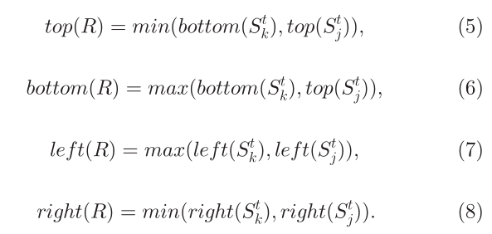

如果（3）或（4）成立，则发生碰撞。 然后我们按如下方式计算碰撞区域 R：不失一般性，我们假设 在图像中的  以下，但两个区域不一定相交（见图 3a 和 3b）。 即top（）≤ top（），假设原点是图像的左上角。 我们定义区域 R 的边界如下：



If collisions occur, we roll back to time t and we set SN and bkof the collision region R to zero. Since there is no force to evolve the boundaries, the two adjacent lines will not merge in this region in future iterations. Finally, we redo the evolution under the new configuration for iteration t + 1.

如果发生碰撞，我们回到时间 t，并将碰撞区域 R 的 SN 和 bk 设置为零。 由于没有力演化边界，两条相邻的线在以后的迭代中不会在这个区域合并。 最后，我们在迭代 t + 1 的新配置下重做进化。

In summary, the procedure operates as follows:

1. Binarize PDFest to obtain initial estimates LS_initial by using the Niblack algorithm [24].
2. Initialize the level set function f by using the initial estimate LS_initial. A simple initialization procedure calculates the distance transform of LS_initial as follows:

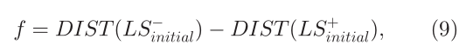

where LS_+_initial(x,y) and LS_-_initial(x,y) represent the regions inside and outside the boundary of LS_initial and DIST() is the distance transform [25] of the respective regions to the boundary. For a pixel inside the boundary, f < 0, and vice versa for a pixel outside the boundary. This is a standard process in the level set method [20]

1. Evolve the initial level set according to the PDE (2).
2. Perform vertical merge detection, as described above.
3. Repeat Steps 3 and 4 until the change between two iterations is small (result converges) or the number of iterations is larger than a predefined limit.

In our experiment, we found that 10 iterations are usually enough to achieve good results. For details of the level set method, refer to [23].

1. 使用Niblack算法[24]二值化PDFest以获得 初始估计LS_initial。
2. 使用初始估计LS_initial 初始化水平集函数 f。 一个简单的初始化过程计算 LS_initial 的距离变换如下



其中 LS_+_initial(x,y) 和 LS_-_initial(x,y) 表示 LS_initial 边界内外的区域，DIST() 是各个区域到边界的距离变换 [25]。 对于边界内的像素，f < 0，对于边界外的像素，反之亦然。 这是水平集方法中的标准过程[20]。

1. 根据偏微分方程（2）演化初始水平集。 
2. 执行垂直合并检测，如上所述。
3. 重复步骤3和4，直到两次迭代之间的变化很小（结果收敛）或迭代次数大于预定义的限制。 在我们的实验中，我们发现 10 次迭代通常足以获得良好的结果。 有关水平集方法的详细信息，请参阅 [23]。
   1. **后处理**

After growing the initial estimate of text lines by using the level set method, most text line boundaries are correctly detected, but a few fragments may still exist (see Fig. 2d) due to extraordinarily large horizontal word gaps. These fragmented pieces can easily be linked to obtain the final text lines by using a rule-based approach similar to [1]. We briefly describe our rule as follows:

1. Assign segments to unique IDs.
2. Calculate the orientation of each line segment by using the minimal mean squared error method.
3. Calculate the length of each line segment. If a text line is shorter than 1/10 of the page length , its orientation is assumed to be horizontal. If the length and the width of a connected component are both smaller than 1/20 of the page length, it is labeled as “isolated.” All text line segments that are not labeled as “isolated” are counted as “unprocessed.”
4. Sort the “unprocessed” text line segments by length.
5. Select the longest “unprocessed” text line segment and extend the line to left or right by using the following merging rules: we merge it to another “unprocessed” line segments if a) the difference in their orientations is less than 10 degrees, b) their bounding boxes’ horizontal gap is less than1 10of the page length, and c) their bounding boxes overlap more than 50 percent in the vertical direction. The ID of the merged segment is then updated. We iteratively apply this rule until there are no more “unprocessed” line segments in left or right, satisfying the merging conditions.
6. Mark all segments involved in Step 4 as “processed.”

7. Go to Step 5 until all line segments have been processed.

在使用水平集方法增加对文本行的初始估计后，大多数文本行边界都被正确检测到，但由于非常大的水平字间距，可能仍然存在一些片段（见图 2d）。 通过使用类似于 [1] 的基于规则的方法，可以轻松地链接这些碎片以获得最终的文本行。 我们简要描述我们的规则如下：

1. 为段分配唯一的ID。
2. 使用最小均方误差法计算每条线段的方向。
3. 计算每条线段的长度。 如果文本行短于页面长度的 1/10，则假定其方向为水平方向。 如果连接组件的长度和宽度都小于页面长度的 1/20，则将其标记为“孤立的”。 所有未标记为“孤立”的文本线段都被视为“未处理”。
4. 按长度对“未处理”的文本线段进行排序。
5. 选择最长的“未处理”文本线段并使用以下合并规则向左或向右延伸线：如果
6. 它们的方向差异小于10度，我们将其合并到另一个“未处理”线段，

b) 它们的边界框的水平间隙小于页面长度的 1/10，并且

c) 它们的边界框在垂直方向上重叠超过 50%。

然后更新合并段的 ID。 我们迭代地应用这个规则，直到左边或右边不再有“未处理”的线段，满足合并条件。

1. 将步骤 4 中涉及的所有段标记为“已处理”。
2. 转到步骤 5，直到处理完所有线段。

Finally, we group the isolated connected components to their closest major text line. We first estimate text line height from the histogram of the heights of the line segments’ bounding boxes . If the distance between the isolated connected components and the closest text line is less than the estimated text line height, we label these isolated components the same as the closest text line. Otherwise, we label those far from any major text line as noise. The estimated text line height need not be very accurate because the isolated components that belong to the characters are usually very close to the text lines (for example, diacritical marks). Fig. 2e shows the result after broken line segment linking and grouping the isolated connected components. Fig. 2f shows the final text line segmentation result by using different colors to distinguish neighboring text lines.

最后，我们将隔离的连接组件分组到它们最近的主要文本行。 我们首先从线段边界框高度的直方图估计文本行高。 如果孤立的连接组件和最近的文本行之间的距离小于估计的文本行高度，我们将这些孤立的组件标记为与最近的文本行相同。 否则，我们将远离任何主要文本行的那些标记为噪声。 估计的文本行高度不需要非常准确，因为属于字符的孤立组件通常非常靠近文本行（例如，音节符号）。 图 2e 显示了虚线段链接和分组隔离连接组件后的结果。 图 2f 显示了使用不同颜色区分相邻文本行的最终文本行分割结果。

After text line boundary evolution using the level set method, linking of the remaining broken lines is easy and reliable because only a few fragmented line segments occur and the average length of a line segment is larger. Table 1 provides statistics about the number of components and average component length at each stage on a handwritten Chinese document set. After boundary evolution, the length of a line segment is almost 20 times that of the connected components on average. The number of components also significantly drops to approximately 1/10 the original number. We further reduce the number of components by grouping broken line segments and isolated small pieces.

使用水平集方法进行文本线边界演化后，剩余折线的链接容易可靠，因为只有少数碎片线段出现，线段的平均长度更大。 表 1 提供了手写中文文档集每个阶段的组件数量和平均组件长度的统计数据。 经过边界演化，一条线段的长度平均几乎是连通分量的 20 倍。 组件的数量也显着下降到原始数量的 1/10 左右。 我们通过对折线段和孤立的小块进行分组来进一步减少组件的数量。

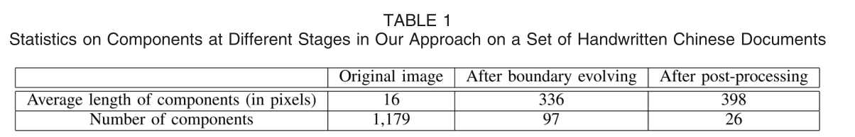

**5 EXPERIMENTS**

* 1. **Data Set**

In this section, we present a quantitative analysis of our algorithm on a large database. The UMD test data set was collected by the members of the Language and Media Processing Laboratory at the University of Maryland.1Hard copies of handwritten documents were collected from many countries such as China, India, Korea, and Japan and were scanned at a resolution of 300 dots per inch (DPI) to binary TIFF images. In summary, 7,528 heterogeneous handwritten documents from 439 writers in nine scripts (Cyrillic, Greek, Hebrew, Hindi, Korean, Japanese, Persian, Chinese, and Thai) have been collected. Table 2 shows some statistics for each script. A typical image size is approximately 2000 × 1500 pixels and the character sizes vary from roughly 10 × 10 to 30 × 30 pixels. We also collected a large data set of Arabic documents containing 166,071 images. We have selected some for our experiments. Fig. 4 shows some examples.

在本节中，我们将在大型数据库上对我们的算法进行定量分析。 UMD 测试数据集由马里兰大学语言和媒体处理实验室的成员收集。手写文档的硬拷贝是从中国、印度、韩国和日本等许多国家收集的，并以分辨率扫描 每英寸 300 点 (DPI) 到二进制 TIFF 图像。 总之，收集了 7,528 份来自 439 位作者的 9 种文字（西里尔文、希腊文、希伯来文、印地文、韩文、日文、波斯文、中文和泰文）的不同种类的手写文件。 表 2 显示了每个脚本的一些统计信息。 典型的图像大小约为 2000 × 1500 像素，字符大小从大约 10 × 10 到 30 × 30 像素不等。 我们还收集了包含 166,071 张图像的大量阿拉伯文文档数据集。 我们为我们的实验选择了一些。 图 4 显示了一些示例。

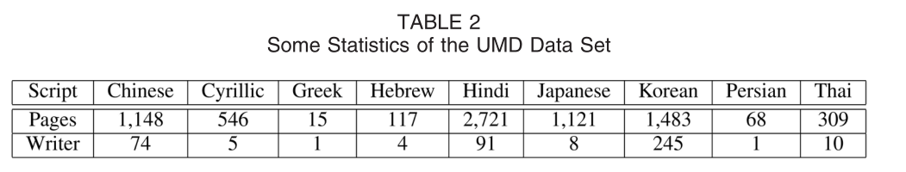

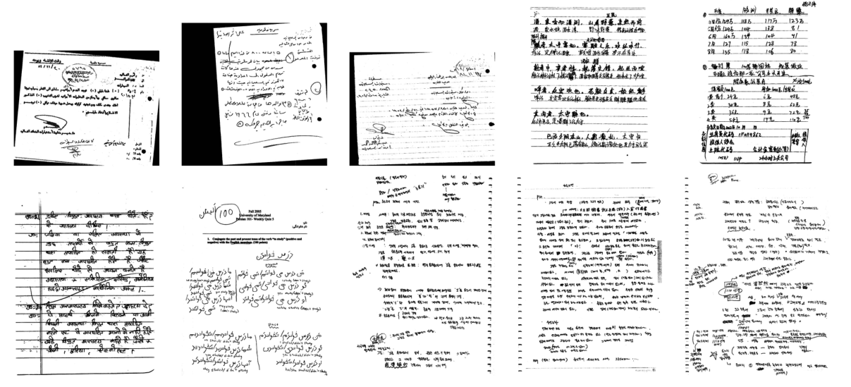

图4. UMD数据集中的手写示例。

* 1. **Overview of the Experiments  实验概述**

We organize our experiments and evaluation as follows: First, we present our evaluation methodology and overall quantitative result on our database and, then, we quantitatively compare our method with other classical methods. To show the robustness of our algorithm, we rotate, scale, and add random noise to images to generate synthesized images and test our algorithm on these synthesized images. Segmented results are visualized using different colors which denote different text lines. Fig. 5 shows the segmentation results of our algorithm on Figs. 1a and 1c. More examples appear in Fig. 6.

我们按如下方式组织我们的实验和评估：首先，我们在我们的数据库中展示我们的评估方法和整体定量结果，然后，我们将我们的方法与其他经典方法进行定量比较。 为了展示我们算法的鲁棒性，我们旋转、缩放和向图像添加随机噪声以生成合成图像并在这些合成图像上测试我们的算法。 分割结果使用不同颜色表示不同的文本行进行可视化。 图 5 显示了我们算法在图 1 和图 2 上的分割结果。 1a 和 1c。 更多示例如图 6 所示。

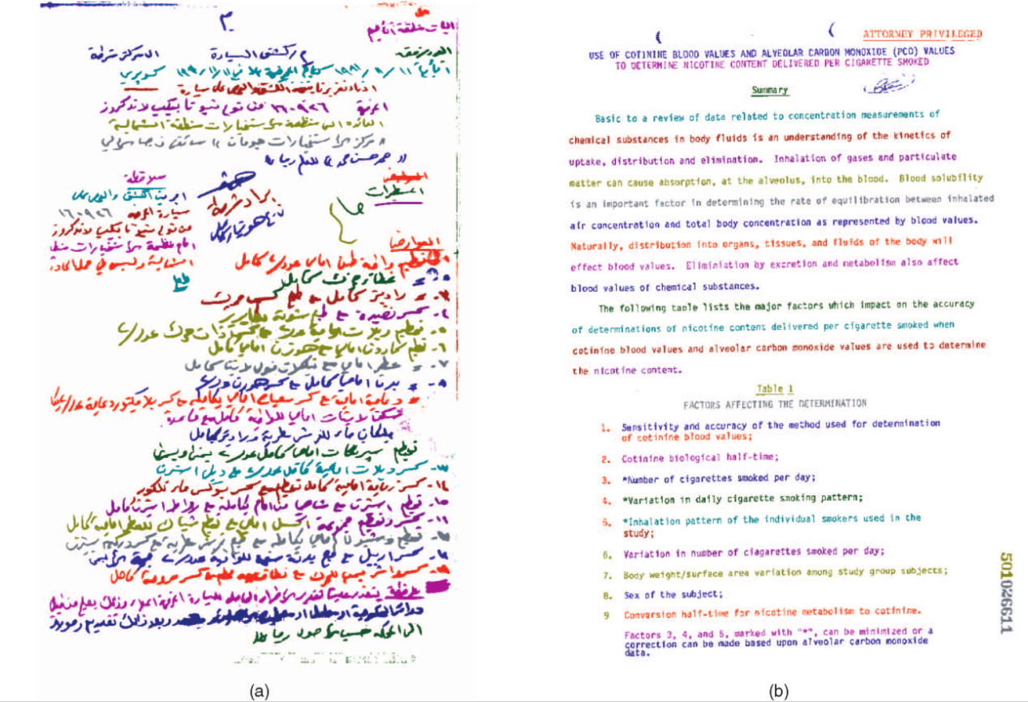

图5.（a）和（b）我们的算法对图5和图5的结果。分别为1A和1C

In all of these experiments, we use the same parameters. Specifically, we use the same Gaussian window and standard deviation for density estimation and the number of iterations for region growth is the same (10 iterations) as well. In our experiment, we set the standard deviations of a 2D Gaussian kernel to 10 and 40 pixels in the horizontal and vertical directions, respectively. Therefore, the size of the truncated window is 30 × 120 pixels according to the discussion in Section 3.2. We also demonstrate how these parameters influence the result at the end of this section and give the best window size for the current data set.

在所有这些实验中，我们使用相同的参数。 具体来说，我们使用相同的高斯窗口和标准偏差进行密度估计，并且区域增长的迭代次数也相同（10 次迭代）。 在我们的实验中，我们将 2D 高斯核的标准偏差在水平和垂直方向分别设置为 10 和 40 个像素。 因此，根据第 3.2 节中的讨论，截断窗口的大小为 30 × 120 像素。 我们还将在本节末尾演示这些参数如何影响结果，并为当前数据集提供最佳窗口大小。

Four scripts—Arabic, Chinese, Hindi, and Korean—are used to illustrate the performance of different methods in Section 5.3. We have ground truthed 100 documents per script by using the VIPER Ground Truth Editor [26]. Since bounding boxes are not sufficiently accurate to delineate the boundary of text lines, we use polygons for the ground truth. In total, there are 7,660 handwritten text lines

四个脚本 - 阿拉伯语，中文，印地文和韩文 - 用于说明5.3节中不同方法的性能。通过使用VIPER地面真相编辑器[26]，我们每个脚本都有100个文件。由于边界框不够准确地描绘文本线的边界，因此我们将多边形用于地面真理。总共有7,660个手写文本线

**5.3评估方法**

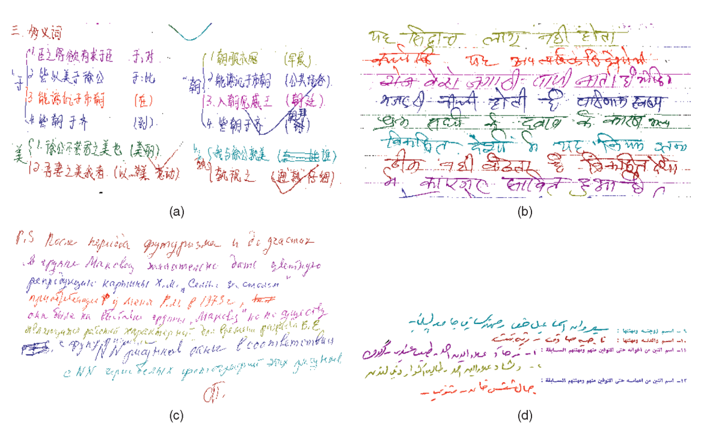

图6.文本线分段结果的颜色示例。 （a）具有不规则文档布局的手写。 （b）具有规则行的手写文本行。 （c）曲线手写文本线条。 （d）与手写和机器印刷文本线混合的文件。

Traditionally in machine printed document analysis, the text line segmentation results are represented as rectangular bounding boxes. Therefore, the evaluation is often based on the four coordinates of a bounding box. However, some overlaps inevitably occur among bounding boxes in curvilinear handwritten documents. Nonoverlapping closed curves are better in the sense of representing curvilinear handwritten text lines. By this representation, the evaluation can be done at the pixel level, which is more accurate than that done at the bounding box level.  
传统上，在机器打印文档分析中，文本行分割结果表示为矩形边界框。 因此，评估往往基于一个边界框的四个坐标。 然而，曲线手写文档中的边界框之间不可避免地会出现一些重叠。 在表示曲线手写文本行的意义上，非重叠闭合曲线更好。 通过这种表示，可以在像素级别进行评估，这比在边界框级别进行的评估更准确。

Supposing there are M ground-truthed lines and N detected lines, we construct an M × N matrix P. An element Pij for i=1,...,M and j =1,...,N of matrix P represents the number of shared black pixels between the ith ground-truthed text line and the jth detected line. We enforce one-to-one correspondence between the detected lines and the ground truth. Since the number of lines in two sets are different in general, we augment the matrix P to a square matrix P’. A line is allowed to be matched to a dummy line and this match has no shared pixels (Pij= 0). The square matrix P’has a dimension max(M,N) × max(M,N). For each assignment of the correspondence for ground truth S（k）, k= 1,..., max(M,N), the goodness G（S） of this assignment is the total number of shared black pixels:

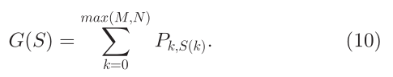

假设有 M 个真实的行和 N 个检测到的行，我们构建一个 M × N 矩阵 P。矩阵 P 的 i=1,...,M 和 j =1,...,N 的元素 Pij 表示 第 i 个真实文本行和第 j 个检测到的行之间共享黑色像素的数量。 我们在检测到的线条和地面实况之间强制执行一一对应。 由于两组中的行数通常不同，我们将矩阵 P 扩充为方阵 P'。 允许一条线与一条虚拟线相匹配，并且该匹配没有共享像素（Pij=0）。 方阵 P' 的维度为 max(M,N) × max(M,N)。 对于ground truth S（k），k= 1,..., max(M,N)的对应关系的每个分配，该分配的优度G（S）是共享黑色像素的总数：



The best assignment So is the one with maximum goodness:

最佳分配So是具有最大优点的分配：

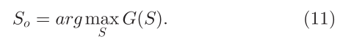

The Hungarian algorithm [27] is used to efficiently search for the assignment problem. The overall pixel-level hit rate is defined as

匈牙利算法 [27] 用于有效搜索分配问题。 整体像素级命中率定义为

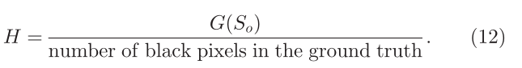

By using the pixel-level hit rate and the Hungarian algorithm, different segmentation errors, for example, splitting, merging, and missing, can be appropriately penalized with weights that are proportional to the number of pixels involved.

We can also evaluate the performance at the text line level. One ground-truthed line i is claimed to be correctly detected if

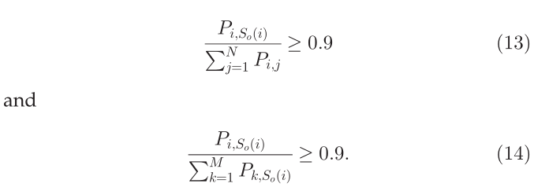

通过使用像素级命中率和匈牙利算法，可以使用与所涉及的像素数成正比的权重来适当地惩罚不同的分割错误，例如分裂、合并和缺失。 我们还可以在文本行级别评估性能。 如果满足以下条件，则声称可以正确检测到一条真实的线路 i



In other words, if a ground-truthed line and the corresponding detected line share at least 90 percent of the pixels with respect to both of them, a text line is claimed to be correctly detected. In the following experiments, we evaluate the performance based on both the pixel-level hit rate and the text-line-level detection rate.

换句话说，如果一个真实的行和相应的检测到的行共享至少 90% 的像素，那么就声称文本行被正确检测到。 在接下来的实验中，我们根据像素级命中率和文本行级检测率来评估性能。

**5.4性能和比较**

We organize our discussion on performance and comparison as follows: First, we briefly show the accuracy on four scripts and, then, we discuss the performance on two different categories, that is, handwriting with and without rule lines. After that, we compare our performance with three other techniques. As a top-down method, the X-Y cut [3] builds a structural tree that represents the document layout. The projection histogram analysis determines the cut in each step. Docstrum [1], on the other hand, builds the layout structure in a bottom-up manner from the connected components. We can therefore retrieve the text line level from the tree structure, although these methods are not solely designed for text line segmentation. Our comparison experiments use a public domain implementation [28] of the X-Y cut and Docstrum algorithms. In addition to these two classical methods, we also test a locally adaptive connected component-based method in DOCLIB [2]. Since the text line segmentation in handwritten documents has not been sufficiently addressed in previous work, we can only compare our approach to those methods that were originally designed for machine printed documents.

我们将我们对性能和比较的讨论组织如下：首先，我们简要展示了四种脚本的准确性，然后我们讨论了两种不同类别的性能，即有和没有规则线的手写。 之后，我们将我们的性能与其他三种技术进行比较。 作为一种自顶向下的方法，X-Y 切割 [3] 构建了一个表示文档布局的结构树。 投影直方图分析决定了每一步的切割。 另一方面，Docstrum [1] 以自底向上的方式从连接的组件构建布局结构。 因此，我们可以从树结构中检索文本行级别，尽管这些方法并不是专门为文本行分割而设计的。 我们的比较实验使用 X-Y 切割和 Docstrum 算法的公共领域实现 [28]。 除了这两种经典方法之外，我们还在 DOCLIB [2] 中测试了一种基于局部自适应连接组件的方法。 由于手写文档中的文本行分割在以前的工作中没有得到充分解决，我们只能将我们的方法与最初为机器打印文档设计的方法进行比较。

In principle, we can train the optimal parameters of an algorithm based on ground truth, as Mao and Kanungo did in [28] for the evaluation of different page segmentation algorithms. As shown in their paper, a robust algorithm often works well under a wide range of parameter inputs. Therefore, in our experiments, we manually tuned parameters for all algorithms based on a few training images and then fixed these parameters for all of the experiments.

原则上，我们可以根据真实情况训练算法的最佳参数，就像Mao 和Kanungo 在[28] 中所做的那样，用于评估不同的页面分割算法。 正如他们的论文中所示，稳健的算法通常在各种参数输入下都能很好地工作。 因此，在我们的实验中，我们根据一些训练图像手动调整所有算法的参数，然后为所有实验固定这些参数。

**5.4.1算法性能**

Our method’s performance for different scripts is shown in Fig. 7, with details listed on the first rows of Tables 3, 4, 5, and 6. Overall, we achieve a 94.7 percent accuracy in terms of the pixel-level hit rate. The standard deviation of the accuracy on all scripts is small, which shows that our algorithm is stable. At the text line level, there are a total of 7,660 ground-truthed lines in Tables 3, 4, 5, and 6 and our approach can correctly detect 6,982 (91.2 percent) of them. Details are shown under the last columns in Tables 3, 4, 5, and 6 . Our algorithm does not use script - dependent information and we set the same parameter for all scripts. A slight degradation in performance is observed on the Arabic documents because they are less constrained (for example, there might not exist consistent base lines for handwritten Arabic text lines (see Fig. 1a)). Due to the inherent differences among scripts, the performances of different scripts could also be slightly different.

我们的方法对不同脚本的性能如图 7 所示，详细信息列在表 3、4、5 和 6 的第一行。总的来说，我们在像素级命中率方面实现了 94.7% 的准确率。 所有脚本的准确度标准偏差都很小，这表明我们的算法是稳定的。 在文本行级别，表 3、4、5 和 6 中共有 7,660 条真实的行，我们的方法可以正确检测其中的 6,982 (91.2%) 行。 详细信息显示在表 3、4、5 和 6 的最后一列下。 我们为所有脚本设置了相同的参数。 在阿拉伯语文档上观察到性能略有下降，因为它们受到的约束较少（例如，手写阿拉伯语文本行可能不存在一致的基线（见图 1a））。 由于脚本之间的固有差异，不同脚本的性能也可能略有不同。

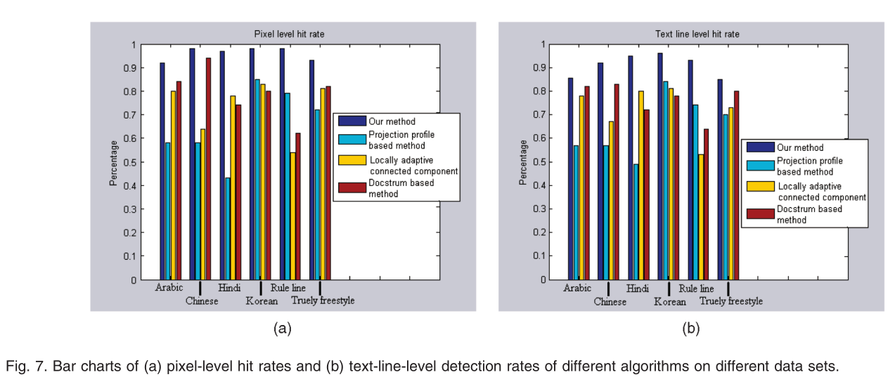

图7.（a）像素级命中率的条形图和（b）不同数据集上不同算法的文本线级检测率

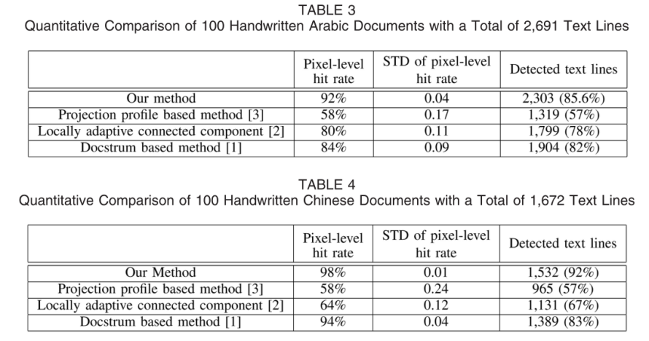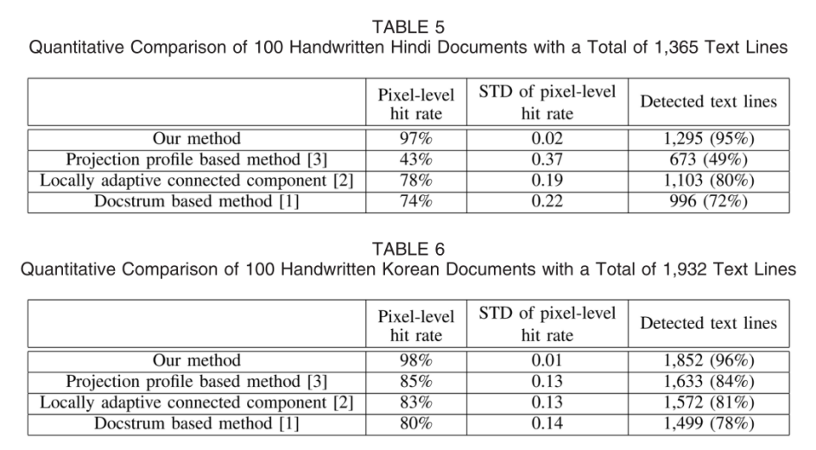

Not all handwritten documents are truly freestyle and written on blank sheets (for example, Fig. 8a). Many, such as lecture notes and some drafts, are written on papers with rule lines (for example, Fig. 8c) and they are more or less constrained by the rule lines. Therefore, we evaluate our performance on both categories. Generally, rule lines make the handwritten text lines straight, but they may also degrade the performance of the connected component analysis because the rule lines may connect arbitrary numbers of adjacent characters. The projection profile analysis may benefit from the rule lines. However, we do not know the geometric relationship between handwritten text lines and rule lines. It may cause errors in profile analysis. For example, writers may ignore the rule lines. As another example, most Chinese handwritings are written over the rule lines, while Hindi tend to overlap the top stroke with the rule lines in our collected database. To evaluate the performance of our algorithm on these two categories, we prepared two sets of documents with and without rule lines, each containing 100 documents chosen from all four scripts. The accuracy of our algorithm on these two mixed sets is shown in the second rows of Tables 7 and 8, respectively. At the text line level, our approach can detect 1,466 out of 1,589 (93 percent) for documents with rule lines and 1,863 out of 2,178 (85 percent) for freestyle documents.

并非所有手写文档都是真正的自由式并写在空白纸上（例如，图 8a）。 许多，例如讲义和一些草稿，是写在带有规则线的论文上（例如，图 8c）并且它们或多或少受到规则线的约束。 因此，我们评估我们在两个类别上的表现。 通常，规则线使手写文本线笔直，但它们也可能降低连通分量分析的性能，因为规则线可能连接任意数量的相邻字符。 投影轮廓分析可受益于规则线。 但是，我们不知道手写文本线和规则线之间的几何关系。 它可能会导致轮廓分析错误。 例如，作者可能会忽略规则行。 再举一个例子，大多数中文笔迹都写在格线上，而印地语倾向于将顶部笔画与我们收集的数据库中的格线重叠。 为了评估我们的算法在这两个类别上的性能，我们准备了两组带有和不带有规则行的文档，每组包含从所有四个脚本中选择的 100 个文档。 我们的算法在这两个混合集上的准确性分别显示在表 7 和表 8 的第二行中。 在文本行级别，我们的方法可以检测到 1,589 个（93%）带有规则行的文档中的 1,466 个，以及自由式文档的 2,178 个（85%）中的 1,863 个。

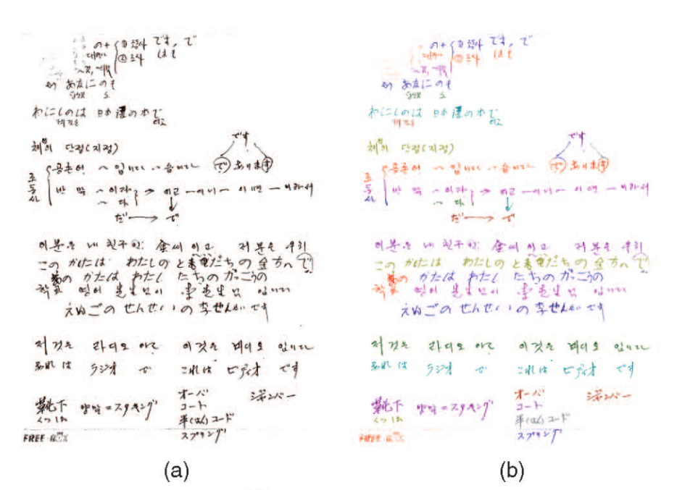

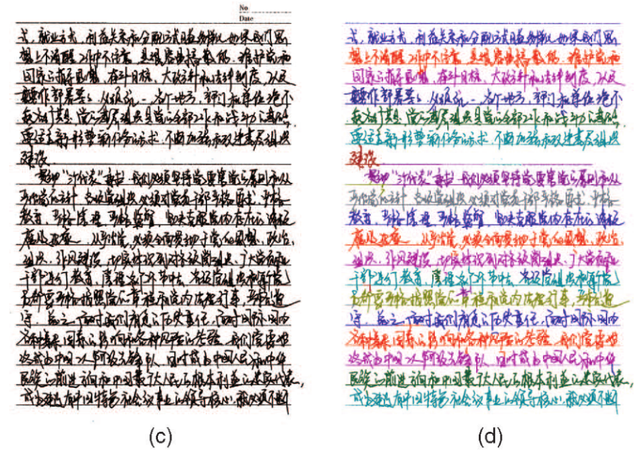

图8.（a）自由式文档图像。 （b）我们（a）算法的结果。 （c）具有规则行的文档图像。 （d）我们（c）算法的结果。

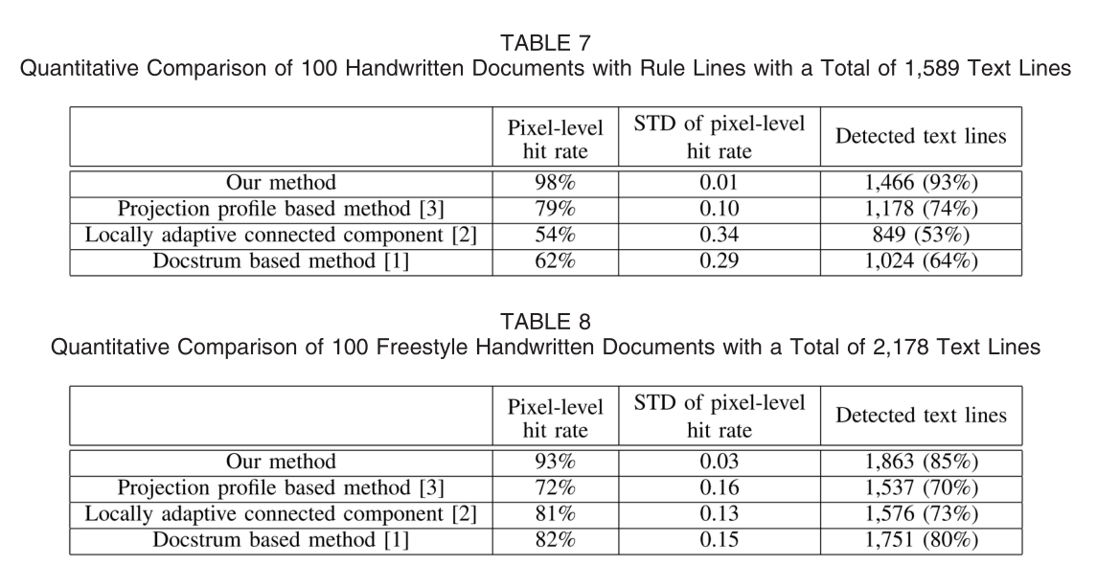

Generally, the majority of failures happen because two neighboring text lines significantly touch each other (for example, see Fig. 9). Since two lines are connected in only a few touched areas, postprocessing to segment them is necessary to improve the performance. We also notice that the correction in the gap between two lines (Fig. 9a) may create many peaks in the density function estimation and it is not trivial to segment them. Other challenges include nontext objects such as stamps, logos, and severe noise. We will measure the effect of noise at the end of this section.

通常，大多数失败的发生是因为两个相邻的文本行彼此明显接触（例如，见图 9）。 由于两条线仅在少数接触区域连接，因此需要对它们进行后处理以提高性能。 我们还注意到，两条线之间间隙的校正（图 9a）可能会在密度函数估计中产生许多峰值，并且对它们进行分割并非易事。 其他挑战包括非文本对象，例如邮票、徽标和严重噪音。 我们将在本节末尾测量噪声的影响。

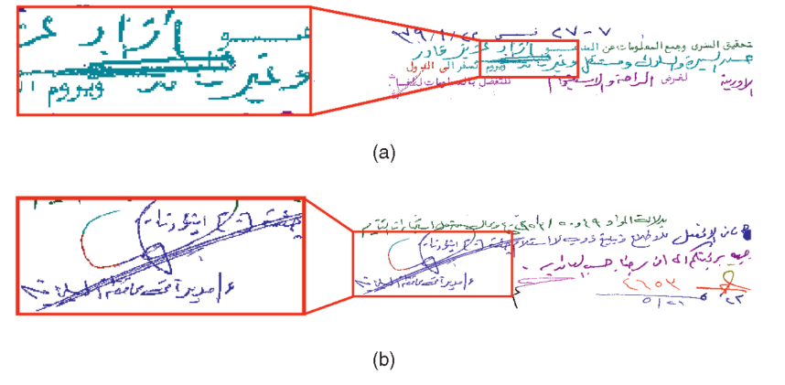

图9.我们的方法的失败示例及其分段结果的特写镜头。

**5.4.2与其他方法的比较**

In this section, we compare our method with three other methods. Some previous work presented the accuracies of their methods at the text line level, but none measured the accuracy at the pixel level. The results of most traditional methods use bounding boxes, which may overlap each other and cause confusion. To make pixel-level evaluation possible, we group pixels in the overlapping area of bounding boxes to the closest text line.

在本节中，我们将我们的方法与其他三种方法进行比较。 之前的一些工作在文本行级别展示了他们方法的准确性，但没有人在像素级别测量准确性。 大多数传统方法的结果使用边界框，可能会相互重叠并造成混淆。 为了使像素级评估成为可能，我们将边界框重叠区域中的像素分组到最近的文本行。

Table 8 shows that the two connected component-based methods perform better on freestyle handwritten documents such as the Arabic and the Hindi, while the projection profile-based method is better on documents with rule lines (Table 7). Comparing the same algorithm in two categories, we observe that the rule lines slightly improve the performance of the projection profile-based method, but they seriously deteriorate the performance of connected component-based methods . We found that connected component-based methods rely on some geometric measures, such as the size of connected components, to filter spurious components (such as small noise dots and big figures on the document) and guide the grouping of neighboring components. The nice property of these geometric measures is destroyed by rule lines. On the contrary, our algorithm does not filter anything before we detect the regions. Projection profile-based methods do not need to find connected components with suitable size as well, but they suffer with complex page layouts and curvilinear lines. Examples are shown in Figs. 10c and 10d. Text lines are often broken or incorrectly merged. In our result (for example, Fig. 10a), most text lines are clearly labeled without confusion.

表 8 显示两种基于连通分量的方法在自由式手写文档（例如阿拉伯语和印地语）上表现更好，而基于投影轮廓的方法在带有规则线的文档上表现更好（表 7）。 在两个类别中比较相同的算法，我们观察到规则线略微提高了基于投影轮廓的方法的性能，但它们严重降低了基于连通分量的方法的性能。 我们发现基于连通分量的方法依赖于一些几何度量，例如连通分量的大小，来过滤虚假分量（例如文档上的小噪声点和大数字）并指导相邻分量的分组。 这些几何度量的优良特性被规则线破坏了。 相反，我们的算法在检测区域之前不会过滤任何内容。 基于投影轮廓的方法也不需要找到合适大小的连接组件，但它们会受到复杂的页面布局和曲线的影响。 示例如图 1 和图 5 所示。 10c 和 10d。 文本行经常被破坏或错误地合并。 在我们的结果中（例如，图 10a），大多数文本行都被清楚地标记，没有混淆。

A good text line segmentation algorithm should process machine -printed documents as well. Fig. 5b shows the segmentation results on a machine printed document without tuning parameters. It shows that our algorithm performs better than or comparably to traditional methods on machine printed documents.

一个好的文本行分割算法也应该处理机器打印的文档。 图 5b 显示了没有调整参数的机器打印文档的分割结果。 它表明我们的算法在机器打印文档上的性能优于或可与传统方法相媲美。

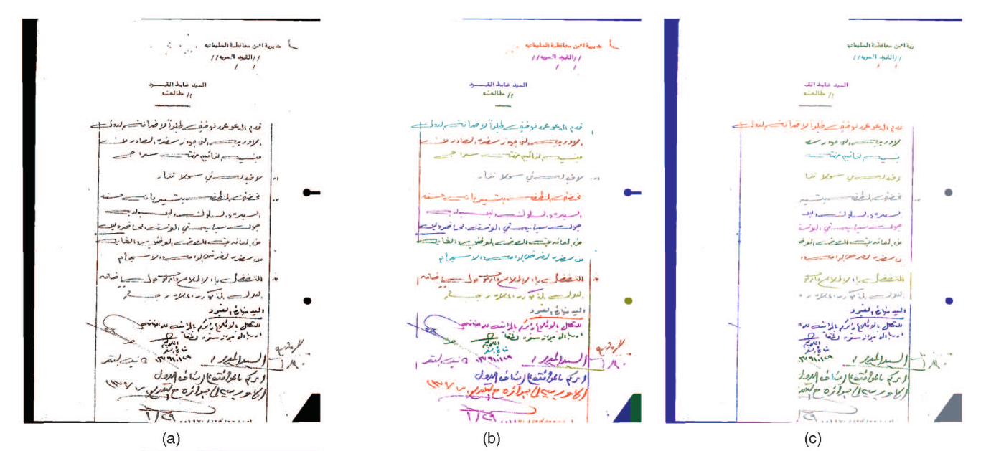

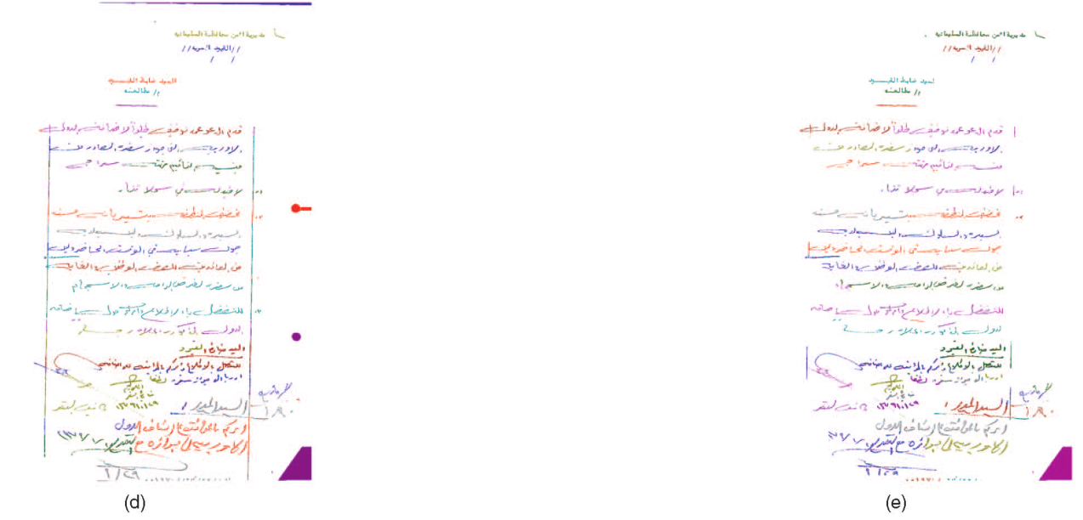

图 10. 与经典方法的比较。 (a) 原始图像。 (b) 我们的方法。 (c) Docstrum 方法[1]。 (d) X-Y 切割法 [3]。 (e) 基于局部自适应连接组件的方法 [2]。

The connected component-based and projection profilebased methods are useful for determining the orientation of zones, size of characters, etc. However they do not work well for handwritten text line segmentation. This comprehensive experiment demonstrates that our method can be used for handwritten documents, machine printed documents, and documents that are a mix of machine printed and handwritten text. Our assumption fits well for both machine printed and handwritten text lines. The statistical results show that our method is better in handwritten documents than classical methods and their variations.

基于连通分量和基于投影轮廓的方法对于确定区域的方向、字符的大小等很有用。但是，它们对于手写文本行分割效果不佳。 这个综合实验表明，我们的方法可用于手写文档、机器打印文档以及机器打印和手写文本混合的文档。 我们的假设非常适合机器打印和手写的文本行。 统计结果表明，我们的方法在手写文档中优于经典方法及其变体。

**5.5 Robustness Test**

In this section, we examine the robustness of our algorithm to both changes in internal parameters and changes in the input. First, the internal parameters are changed in a wide range. Then, the external input is varied by rotation and scale. We then present the results on synthesized images with different noise levels.

在本节中，我们将检查我们的算法对内部参数变化和输入变化的稳健性。 一是内部参数变化范围大。 然后，外部输入随旋转和缩放而变化。 然后我们在具有不同噪声水平的合成图像上展示结果。

**5.5.1关于内部参数的鲁棒性**

Two major components comprise our algorithm: the Parzen window-based density estimation and boundary evolution. The region’s evolutions become slow in the text line boundaries due to the low value of the PDF and, if a region has a zero value, the boundary will stop at the region. Our approach is very stable under a reasonable number of iterations. In experiments, we did not find a significant difference, even if we increase the iteration number from 10 to 50. We therefore evaluate the Parzen window size in the following.

我们的算法有两个主要组成部分：基于 Parzen 窗口的密度估计和边界演化。 由于 PDF 的值较低，该区域在文本行边界的演变变慢，如果某个区域的值为零，则边界将在该区域处停止。 我们的方法在合理的迭代次数下非常稳定。 在实验中，我们没有发现显着差异，即使我们将迭代次数从 10 增加到 50。因此我们在下面评估 Parzen 窗口大小。

We change the window size while keeping the standard deviations proportional to the window size. This way, we evaluate the performance of internal parameters. Fig. 11 shows the performance of different Parzen windows. The accuracy is visualized using a color map. The x axis is the width of the kernel window, while the y axis is the height of the kernel window. The best size of the kernel window is 30 × 120 in our case. In all of our experiments, we maintain these values.

我们改变窗口大小，同时保持标准偏差与窗口大小成比例。 通过这种方式，我们评估了内部参数的性能。 图 11 显示了不同 Parzen 窗口的性能。 使用颜色图将精度可视化。 x 轴是内核窗口的宽度，而 y 轴是内核窗口的高度。 在我们的例子中，内核窗口的最佳大小是 30 × 120。 在我们所有的实验中，我们都保持这些值。

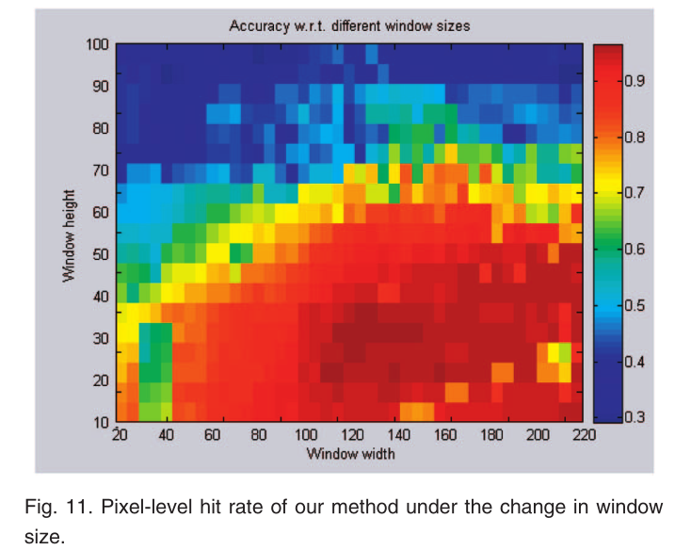

图11.我们在窗口大小的变化下的方法的像素级命中率

**5.5.2规模和旋转变化的性能**

Our algorithm is not theoretically scale invariant or rotation invariant. In the following experiments, we test our method on synthesized images under the changes in scale and rotation on the four annotated data sets. The character size within images is affected by 1) the scanning resolution and 2) the font size. Therefore, we can evaluate the sensitivity of our method by resizing the image to mimic the change in character size. Fig. 12 shows the accuracy for different scales. It shows that our algorithm produces similar results with different character sizes. One example appears in Fig. 13.

我们的算法在理论上不是尺度不变或旋转不变的。 在接下来的实验中，我们在四个带注释的数据集的缩放和旋转变化下，在合成图像上测试我们的方法。 图像中的字符大小受 1) 扫描分辨率和 2) 字体大小的影响。 因此，我们可以通过调整图像大小来模拟字符大小的变化来评估我们方法的敏感性。 图 12 显示了不同尺度的准确度。 它表明我们的算法在不同的字符大小下产生了相似的结果。 一个例子出现在图 13 中。

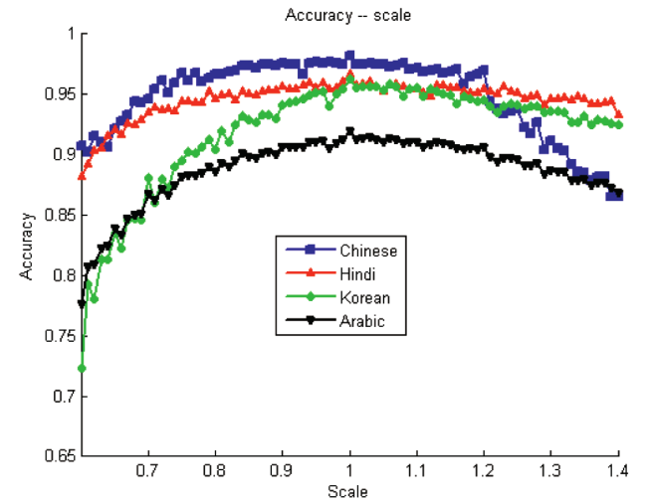

图12.我们在规模变化下的方法的像素级命中率。

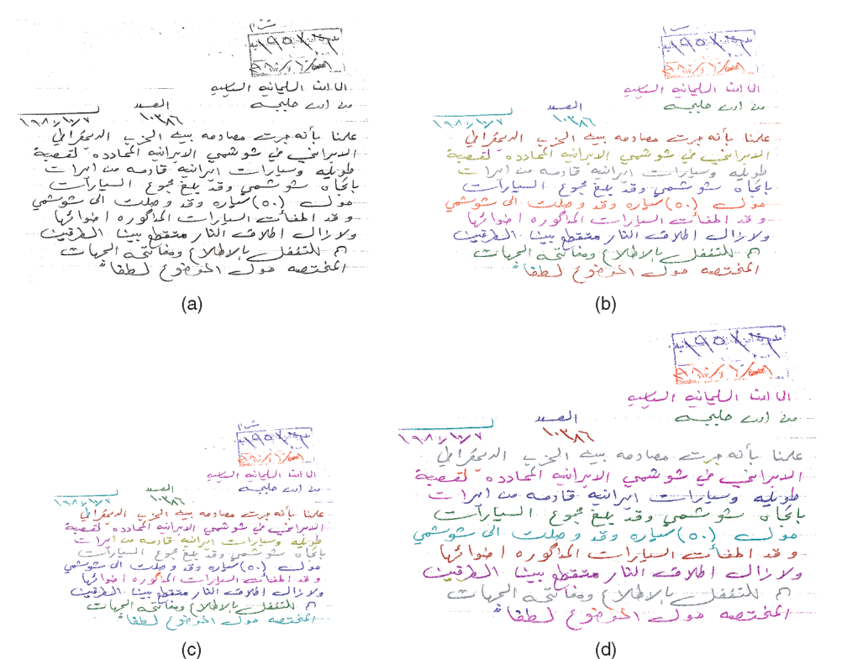

图 13. 不同尺度文档的分割结果。 (a) 原始图像。 (b) 原始图像的结果。 (c) 缩放至 80% 的图像结果。 (d) 缩放至 120% 的图像结果。

To illustrate how the skew degrades the performance, we rotate an image using different angles and compare the accuracy. Fig. 14 shows the quantitative evaluation under different rotation angles and Fig. 15 shows one example under three different rotation angles. The performance of our algorithm does not significantly degrade when the orientation changes within [-10,10] degrees. For most deskewed handwritten documents, the skew falls into this range. Experiments show that our algorithm can fit, in most cases, with a deskew module as preprocessing.

为了说明倾斜如何降低性能，我们使用不同的角度旋转图像并比较精度。 图14显示了不同旋转角度下的定量评估，图15显示了三种不同旋转角度下的一个例子。 当方向在 [-10,10] 度内变化时，我们算法的性能不会显着降低。 对于大多数歪斜的手写文档，歪斜都在这个范围内。 实验表明，在大多数情况下，我们的算法可以使用去歪斜模块作为预处理。

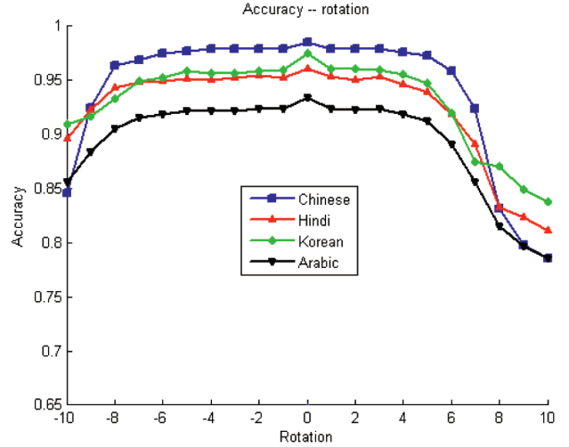

图14.我们在旋转角度变化下的方法的性能。

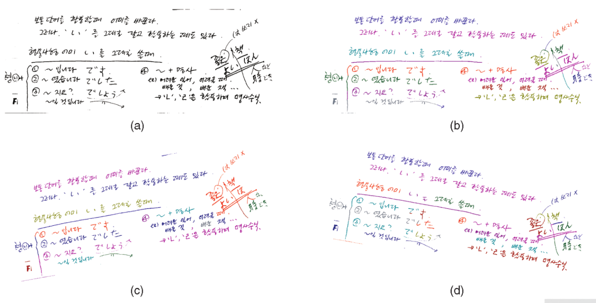

图 15. 具有不同旋转的文档的分割结果。 (a) 原始图像。 (b) 原始图像的结果。 (c) 图像旋转 10 度后的结果。 (d) 图像旋转 10 的结果？

By using the best internal parameters, as discussed in Section 5.5.1, we observe small peaks in Figs 12 and 14. Overall, our performance shows that it can tolerate input changes to some extent. The density estimation is not sensitive to scale and rotation. Our algorithm is designed for curvilinear text lines, so it can still output the expected result when the rotation is not significant (for example,±10°).

通过使用最佳内部参数，如第 5.5.1 节所述，我们观察到图 12 和 14 中的小峰值。总的来说，我们的性能表明它可以在一定程度上容忍输入变化。 密度估计对缩放和旋转不敏感。 我们的算法是为曲线文本行设计的，因此在旋转不显着时（例如±10°），它仍然可以输出预期的结果

**5.5.3噪音下的性能**

Noise is a major issue in many computer vision problems. It can significantly degrade the result. In our method, it mainly leads to inaccurate density estimation. In principle, a good noise model can be integrated in the density estimation module to compensate for the degradation and improve the accuracy.

噪声是许多计算机视觉问题中的主要问题。 它会显着降低结果。 在我们的方法中，它主要导致密度估计不准确。 原则上，可以在密度估计模块中集成一个好的噪声模型来补偿退化并提高精度。

In this experiment, we demonstrate the performance by using salt-and-pepper noise. By randomly flipping the pixels in binary images, we can perform simulations with different probabilities. Fig. 17 shows three images with different noise levels. Fig. 16 gives a statistical analysis of accuracy in terms of different noise probabilities for the four scripts. Results show that our algorithm elegantly degrades under noise and noise reduction and text restoration [29], [30], [31] are helpful but are beyond the scope of our paper. We have implemented our algorithm in C++. The average processing time for an image with the size of approximately 2;000 ? 1;500 pixels nears 20 s on a PC with a 1.6 GHz CPU and 1-Gbyte memory. Our algorithm is relatively slow compared to other algorithms. The most time-consuming part of our algorithm involves the computation of the partial derivatives in boundary evolution. A more efficient implementation with the fast marching methods [32] may significantly speed up the algorithm.

在这个实验中，我们通过使用椒盐噪声来演示性能。 通过随机翻转二进制图像中的像素，我们可以执行不同概率的模拟。 图 17 显示了具有不同噪声水平的三幅图像。 图 16 给出了四种脚本在不同噪声概率方面的准确性的统计分析。 结果表明，我们的算法在噪声和降噪和文本恢复 [29]、[30]、[31] 下优雅地降级是有帮助的，但超出了我们论文的范围。 我们已经在 C++ 中实现了我们的算法。 大小约为 2,000 的图像的平均处理时间？ 在配备 1.6 GHz CPU 和 1 GB 内存的 PC 上，1;500 像素接近 20 秒。 与其他算法相比，我们的算法相对较慢。 我们算法中最耗时的部分涉及计算边界演化中的偏导数。 使用快速行进方法 [32] 的更有效实现可能会显着加快算法速度。

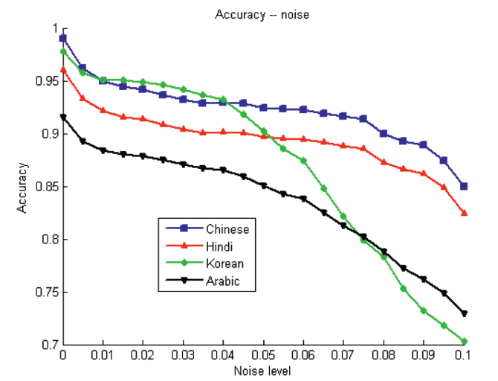

图16.我们在噪声水平变化下的方法的性能

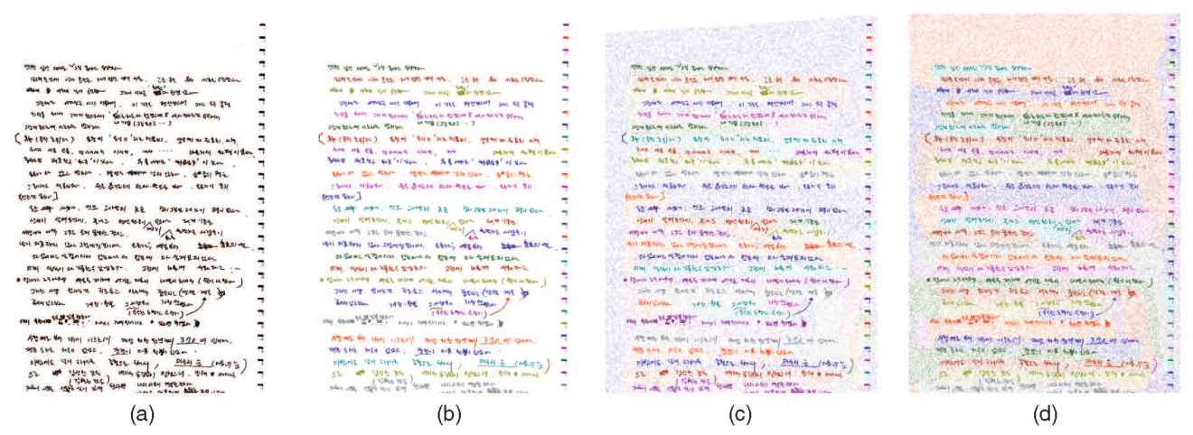

图17.具有不同图像质量的文档的分段结果。 （a）原始图像。 （b）原始图像结果。 （c）图像噪音5％的结果。 （d）图像噪声10％的结果。

**6讨论，结论和未来的工作**

In this paper, we proposed a novel and robust text line segmentation approach for freestyle handwritten documents. Extensive comparison experiments show that the proposed method consistently outperforms the traditional text line segmentation methods such as the projection-based top-down approaches and connected component-based bottom-up approaches. Our approach is script independent since no script-specific knowledge is used in our approach. We achieve consistently high accuracy on many scripts, such as Arabic, Hindi, Chinese, and Korean, by using the same parameter settings. Experiments show that our algorithm is robust and it elegantly degrades under the changes in scales, rotation, and noise. Although it was originally developed with a binary image in mind, our algorithm can extend to gray-scale and color document images without major changes. The time complexity for processing gray-scale images is the same as that for binary ones. For color images, the time complexity is three times that for binary ones in the probability map estimation because the algorithm needs to combine three channels, while it is the same in the remaining processing steps.

在本文中，我们为自由式手写文档提出了一种新颖且强大的文本行分割方法。 大量的比较实验表明，所提出的方法始终优于传统的文本行分割方法，例如基于投影的自顶向下方法和基于连接组件的自底向上方法。 我们的方法是独立于脚本的，因为我们的方法中没有使用特定于脚本的知识。 通过使用相同的参数设置，我们在许多脚本（例如阿拉伯语、印地语、中文和韩语）上实现了始终如一的高精度。 实验表明，我们的算法是鲁棒的，并且在尺度、旋转和噪声的变化下它会优雅地降级。 尽管它最初是在考虑二进制图像的情况下开发的，但我们的算法可以扩展到灰度和彩色文档图像而无需进行重大更改。 处理灰度图像的时间复杂度与处理二值图像的时间复杂度相同。 对于彩色图像，在概率图估计中时间复杂度是二进制图像的三倍，因为该算法需要组合三个通道，而在其余处理步骤中时间复杂度相同。

Our approach combines the advantages of both the bottom-up approaches and the top-down ones. First, our approach does not require the layout information a priori, having the same advantage as many bottom-up methods. Based on the probability map of the text lines, the boundaries automatically grow, merge, and stop. Therefore, we can deal with complicated document layouts. Second, we do not assume particular scripts as input, which is an attractive advantage, as in many top-down methods. We consider pixels, instead of characters, in our approach and estimate the unknown PDF of every document image. Therefore, our approach is script independent.

我们的方法结合了自底向上方法和自顶向下方法的优点。 首先，我们的方法不需要先验布局信息，具有与许多自底向上方法相同的优势。 基于文本行的概率图，边界自动增长、合并和停止。 因此，我们可以处理复杂的文档布局。 其次，我们不假设特定的脚本作为输入，这是一个有吸引力的优势，就像在许多自上而下的方法中一样。 我们在我们的方法中考虑像素而不是字符，并估计每个文档图像的未知 PDF。 因此，我们的方法是独立于脚本的。

We observed that adjacent text lines may merge in our method if they significantly touch each other. This wrong merge can be detected because the segmented text line has an abnormal height. Further postprocessing can be developed to detect the touching area and separate the merged text lines. Under severe noise, the performance of the proposed method deteriorates. Document enhancement techniques may be exploited to improve the performance.

我们观察到，如果相邻的文本行彼此显着接触，它们可能会在我们的方法中合并。 可以检测到此错误合并，因为分段文本行具有异常高度。 可以开发进一步的后处理来检测触摸区域并分离合并的文本行。 在严重的噪声下，所提出的方法的性能恶化。 可以利用文档增强技术来提高性能。

**总结：**

第一篇从密度估计角度研究文本行分割问题，提出了一种基于密度估计的新方法和一种最新的图像分割技术-水平集方法，从输入文档图像中，我们估计一个概率图，其中每个元素表示底层像素属于文本行的概率。然后利用水平集方法通过进化初始估计来确定相邻文本行的边界。与基于连通组件的方法(例如，[1]和[2])不同，所提出的算法不使用任何特定于脚本的知识。在阿拉伯、中文、朝鲜语和印地语等多种文字的自由式手写文档上始终优于以前的方法。该算法对尺度变化、旋转和噪声具有较强的鲁棒性。

**步骤：**

1. 密度估计：（采用高斯核，Parzen窗口技术）

细节：**使用各向异性核的密度估计，**文本行上具有高密度值（暗)，但对于间隙具有低密度值（亮）。采用高斯核，Parzen窗口技术保证了结果PDF的连续性和平滑性，有利于边界选择。与文本行分割任务无关的细节，如脚本、文本内容和单词间隙已经模糊，而文本行结构得到增强。

2、对文本行进行初始估计。 具有高密度值的像素允许进行合适的初始估计（使用Niblack算法二值化PDFest（概率图）以获得 初始估计LS_initial。）

3、使用初始估计LS_initial 初始化水平集函数 f



1. 根据偏微分方程演化初始水平集。

其中 LS_+_initial(x,y) 和 LS_-_initial(x,y) 表示 LS_initial 边界内外的区域，DIST() 是各个区域到边界的距离变换 [25]。 对于边界内的像素，f < 0，对于边界外的像素，反之亦然。 这是水平集方法中的标准过程[20]。

细节：水平集利用先验知识：

①文本行往往是有方向的（例如，在我们的例子中是水平的）。 我们可以调整水平集方法来利用这个先验知识。水平更新步长 设置 为大于 垂直步长 来强制边界在水平方向上增长得更快。

②曲率采用一种称为“富者愈富”的策略：中的bk设置为实际曲率的平方。 根据我们的假设，文本行被水平拉长； 因此，边界的左右两端的曲率大于顶部和底部的曲率，这意味着文本行在水平方向上的增长速度更快。

5、执行垂直合并检测。

细节：如果发生碰撞，我们回到时间 t，并将碰撞区域 R 的 SN 和 bk 设置为零



6、 重复步骤3和4，直到两次迭代之间的变化很小（结果收敛）或迭代次数大于预定义的限制。 在我们的实验中，我们发现 10 次迭代通常足以获得良好的结果。

**后处理**

在使用水平集方法增加对文本行的初始估计后，大多数文本行边界都被正确检测到，但由于非常大的水平字间距，可能仍然存在一些片段。 规则如下：

1. 为段分配唯一的ID。
2. 使用最小均方误差法计算每条线段的方向。
3. 计算每条线段的长度。 如果文本行短于页面长度的 1/10，则假定其方向为水平方向。 如果连接组件的长度和宽度都小于页面长度的 1/20，则将其标记为“孤立的”。 所有未标记为“孤立”的文本线段都被视为“未处理”。
4. 按长度对“未处理”的文本线段进行排序。
5. 选择最长的“未处理”文本线段并使用以下合并规则向左或向右延伸线：如果
6. 它们的方向差异小于10度，我们将其合并到另一个“未处理”线段，

b) 它们的边界框的水平间隙小于页面长度的 1/10，并且

c) 它们的边界框在垂直方向上重叠超过 50%。

然后更新合并段的 ID。 我们迭代地应用这个规则，直到左边或右边不再有“未处理”的线段，满足合并条件。

1. 将步骤 4 中涉及的所有段标记为“已处理”。
2. 转到步骤 5，直到处理完所有线段。

**概率图的动机：**

计算机算法不一定模仿人类行为，但人类行为可能会给我们一些见解，以探索更好的算法。 当人类在文档中写入文本行时，自然会出现某种模式。 例如，一个段落内的书写速度可能几乎保持不变，因此两个相邻文本行之间的距离通常是相似的。 这促使我们考虑生成此模式的 PDF。 我们不是直接对二值图像进行分割，而是将其转换为概率图，其中每个元素表示该像素属于文本行的概率。

这种估计的概率图提供了许多工作优势。 我们可以避免在开始时计算一些几何属性，例如质心和连通分量大小，因为它们对于手写文档不准确。 另一个优点是我们可以采用许多最先进的算法来分析二维密度函数。

**本文注意点：**

基于连通组件方法：使用特定于脚本的知识。且直接作用于输入图像（二值化图像），对于连通分量分析，每个像素都同等的对待，一个像素的变化可能导致不同的结果（采用概率方法处理这个问题）